Mailroom Standard Operating Procedures
Table of Contents
- Receiving
  - Purpose
  - Procedure
    - Freight Shipments
    - Small package/trackable envelopes
- Package Screening (X-Ray Machine)
  - Purpose
  - Procedure
- Inbound
  - Purpose
  - Procedure
    - Hot Packages.
    - Packages for other buildings.
    - Packages with names, not in system, but in HR TECH.
    - Packages with names, not in system, not in HR TECH.
    - Packages with no names.
- Ergo Equipment
  - Purpose
  - Procedure
- IT Equipment (CDW Specific)
  - Purpose
  - Procedure
- Miscellaneous
  - Purpose
  - Procedure
- Mail Sorting
  - Purpose
  - Procedure
    - Certified Mail.
    - List of POC for specific mail.
- Delivery
  - Purpose
  - Procedure
- Legal Mailroom (Lockers)
  - Purpose
  - Procedure
- Email Inquiries
  - Purpose
  - Procedure
- Interoffice/Interoffice Vehicle
  - Purpose
  - Procedure
- Hold at Location
  - Purpose
  - Procedure
- Hold at Location/Events
  - Purpose
  - Procedure
- Not in System
  - Purpose
  - Procedure
- Return to Sender
  - Purpose
  - Procedure
- Outbound
  - Purpose
  - Procedure
- Reports
  - Purpose
  - Procedure
- Site Specific Miscellaneous
  - Purpose
  - Procedure

1. Receiving
Purpose:
To handle and identify packages and shipments delivered to the CLIENT mailroom facilities from couriers such as, FedEx Express, FedEx Ground, UPS, USPS, DHL, On-Trac and other specialized couriers.
Procedure:
- Freight Shipments.
  - Physically verify the total number of pieces that are being delivered by the delivery carrier via Handheld Scanner, Bill of Lading or Delivery Receipt. (See sample below.)
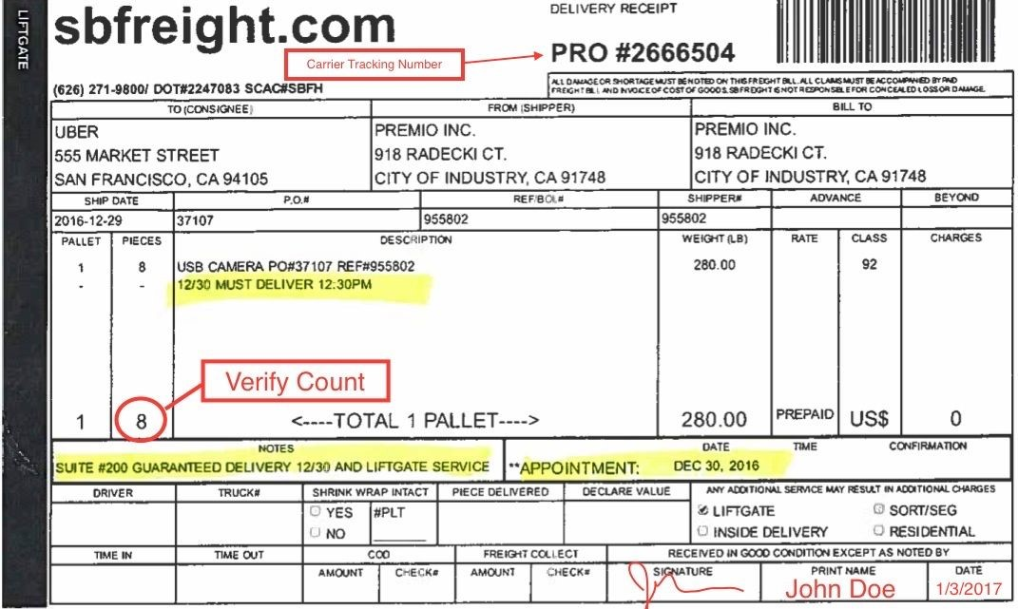
  - If there are any exceptions, such as damaged external packaging or opened boxes, make sure to have the delivery driver notate it in their scanner or Bill of Lading Receipt.
    - For shortages, you will need to cross out the incorrect quantity and note the actual quantity received. (See sample at top of next page.)
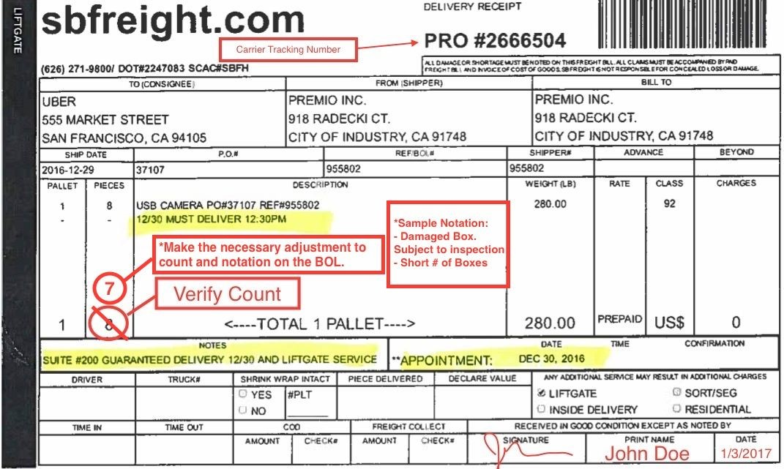
    - For damaged boxes, note Carrier and Customer Receipts, the number of packages that are damaged, as well as “Subject to inspection.”
    - Take photos of the condition of the packages for claims purposes if necessary.
  - Always notate any discrepancies with the carrier prior to signing any paperwork or scanner.
- Small package and trackable envelopes.
  - Physically verify the total number of packages that are being delivered by the delivery carrier via Handheld Scanner or Delivery Receipt.
  - Make sure that each package is going to CLIENT and do not accept any other packages that are not for CLIENT.
  - If there are exceptions, such as damaged external packaging or opened boxes, make sure to have the delivery driver notate it in their scanner or paperwork.
  - Take photos of the condition of the the packaging for claims purposes if necessary.
  - Always notate any discrepancies with the carrier prior to signing scanner or paperwork.
- Manually create a label for shipment on XXX. For example in the tracking number field “ItemDate” ie 50Monitors01142019 and in notes number of pallets received.

2. Package Screening (X-Ray Machine)
Purpose:
To identify suspicious packages that could be used to harm customers and fellow employees while following protocols to ensure the careful handling in the event of its discovery.
Procedure:
- Indicators of a suspicious package or mail:
  - Inappropriate or unusual labelling, such as:
    - Excessive postage.
    - Misspelled common words.
    - No return address or strange return address.
    - Unusual addressing, such as not being addressed to a specific person, the use of incorrect titles or titles with no name.
    - Restrictive markings, such as “personal,” “confidential,” or “do not x-ray.
  - Unusual or inappropriate appearance:
    - Powdery substances felt through or appearing on the package/mail.
    - Oily stains or discoloration on the exterior.
    - Strange odors.
    - Excessive packaging material, such as tape or string.
    - Lopsided or bulky shape of envelopes or boxes.
    - Ticking sounds, protruding wires or exposed aluminum foil.
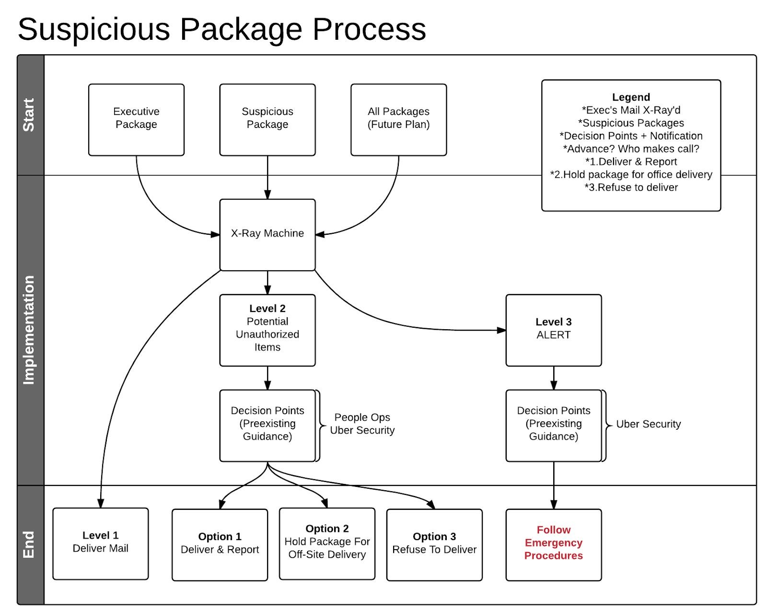
- Place all packages that have been received through the X-Ray machine.
  - Make sure to wear the radiation indicator badge before operating the X-Ray machine. (See Picture below)
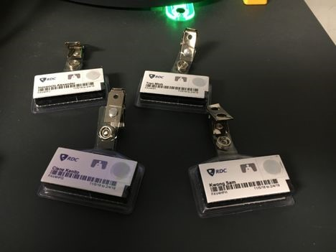
  - Turn on the machine by pressing the “White Left Arrow.” (see Picture Below)
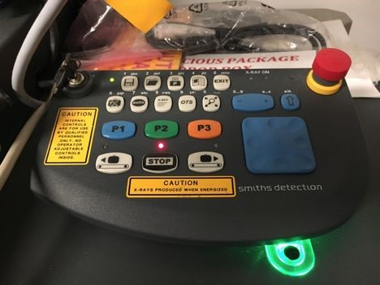
  - Place the package on the conveyor belt on the right side of the machine and push the package through, but DO NOT put your hands inside the machine. Use another package to move it along or use the piece of wood to push if stuck.
  - View the screen as the package goes through the machine to identify any potential threats.
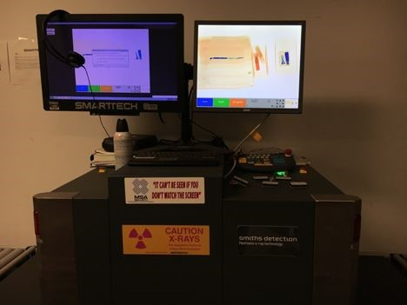
  - Use the following X-Ray Color Key for color reference and guidance.
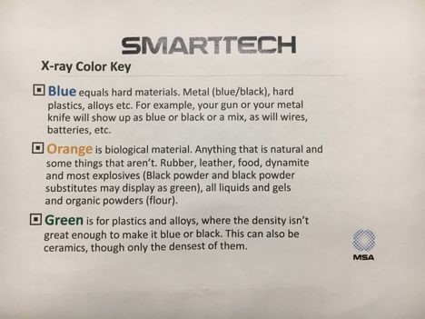
  - Examples.
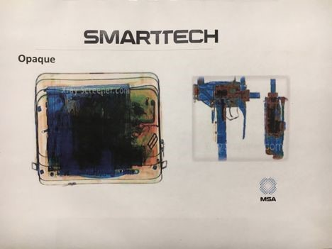
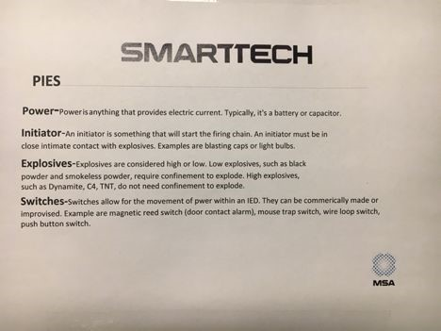
  - When in doubt, call the xxx.
- In the event of discovering any of the above indicators and verify a suspicious package/mail, proceed with the follow instructions.
  - Remain calm.
  - Do not open or shake the package/letter.
  - Place the package in the designated area.
  - Contact xxx at 1-xxx-xxx-xxxx.

3. Inbound
Purpose:
To scan ​ALL​ delivered packages with a tracking label received by courier into the XXX system to obtain customer delivery location information and provide label for end delivery.
Procedure:
- Access the XXX program.
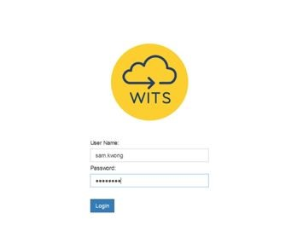
- Type in your User Name and Password, then click on the Login button.
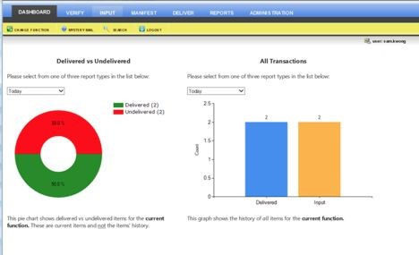
- At the Dashboard Screen, click on the INPUT tab located at the top of the screen.
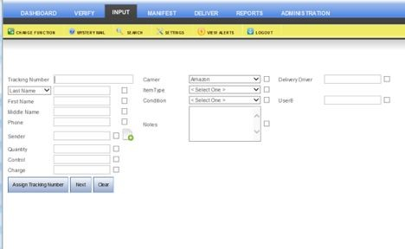
- Place cursor on the Tracking Number Field.
- Using the scan gun, scan the barcode of the appropriate tracking label. Samples of tracking labels on the next few pages.
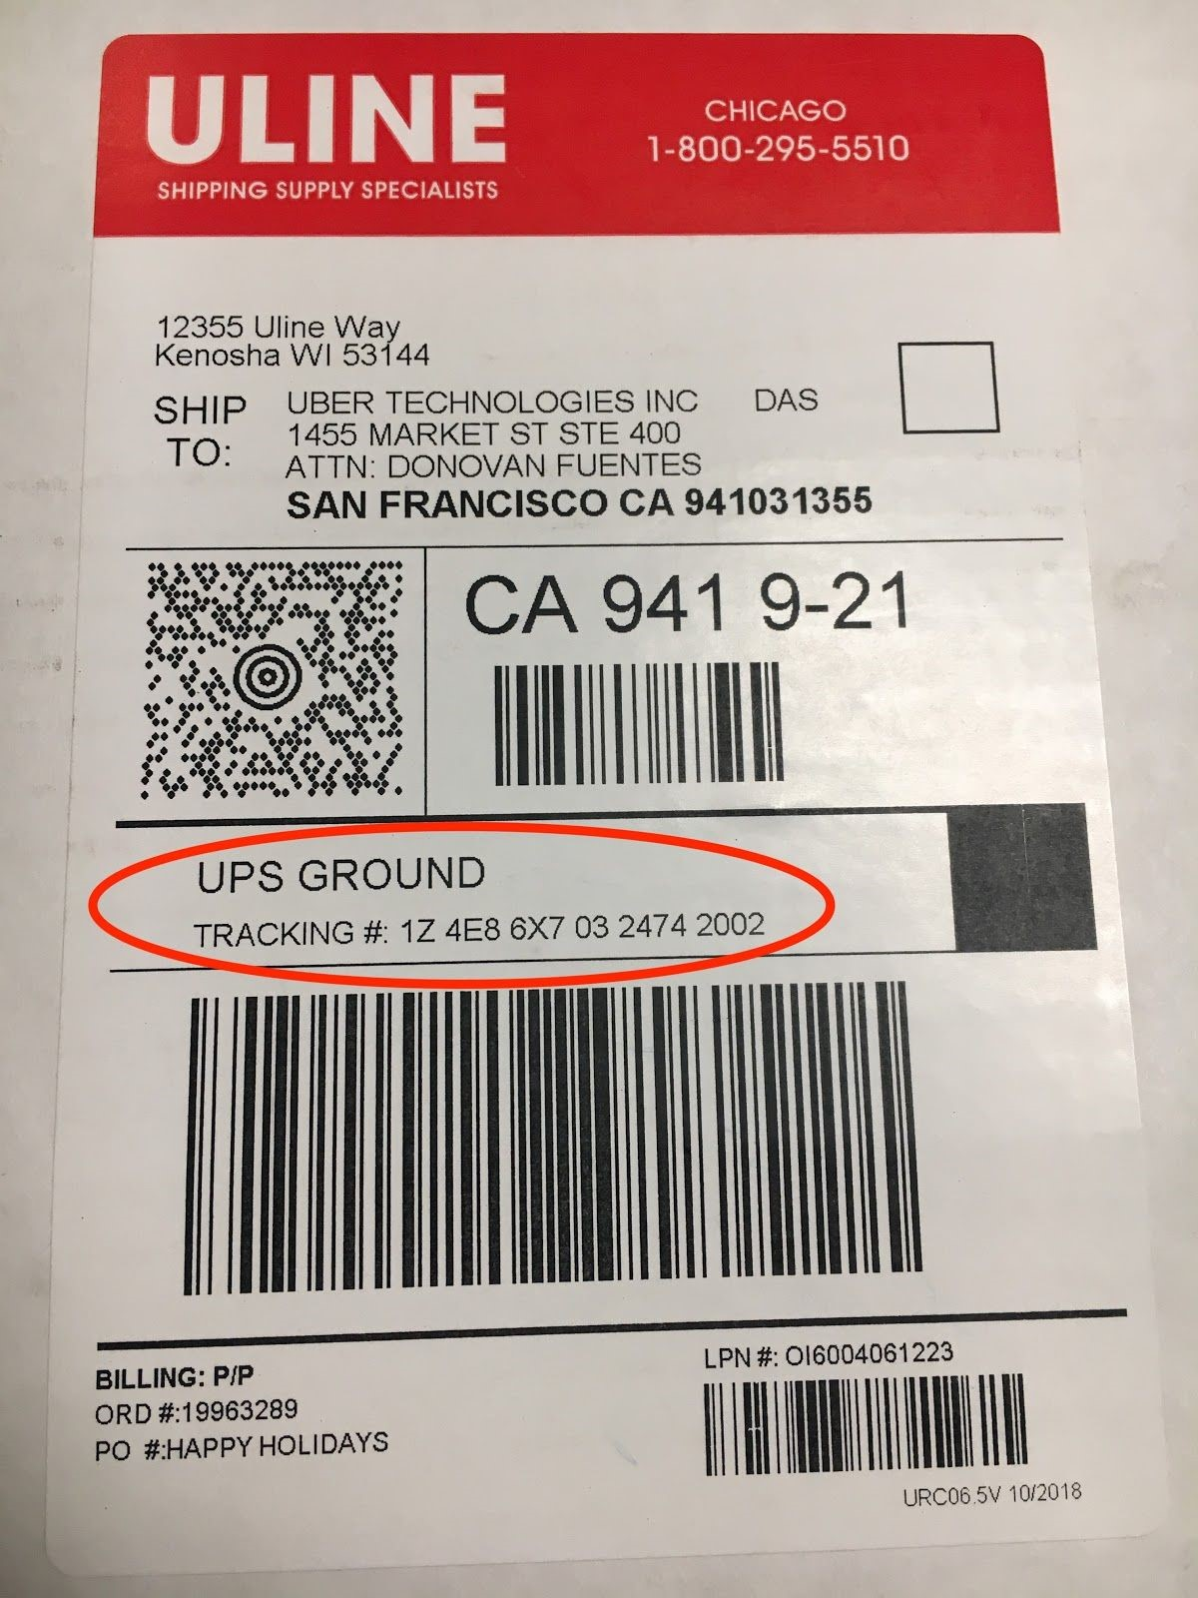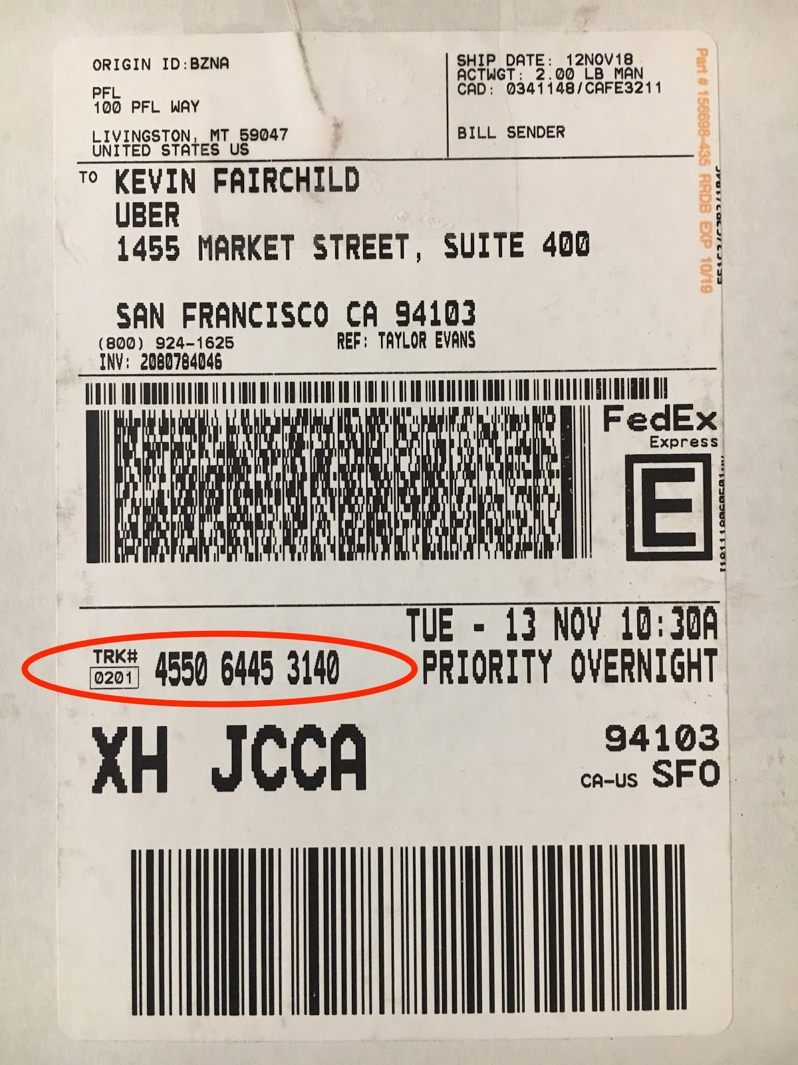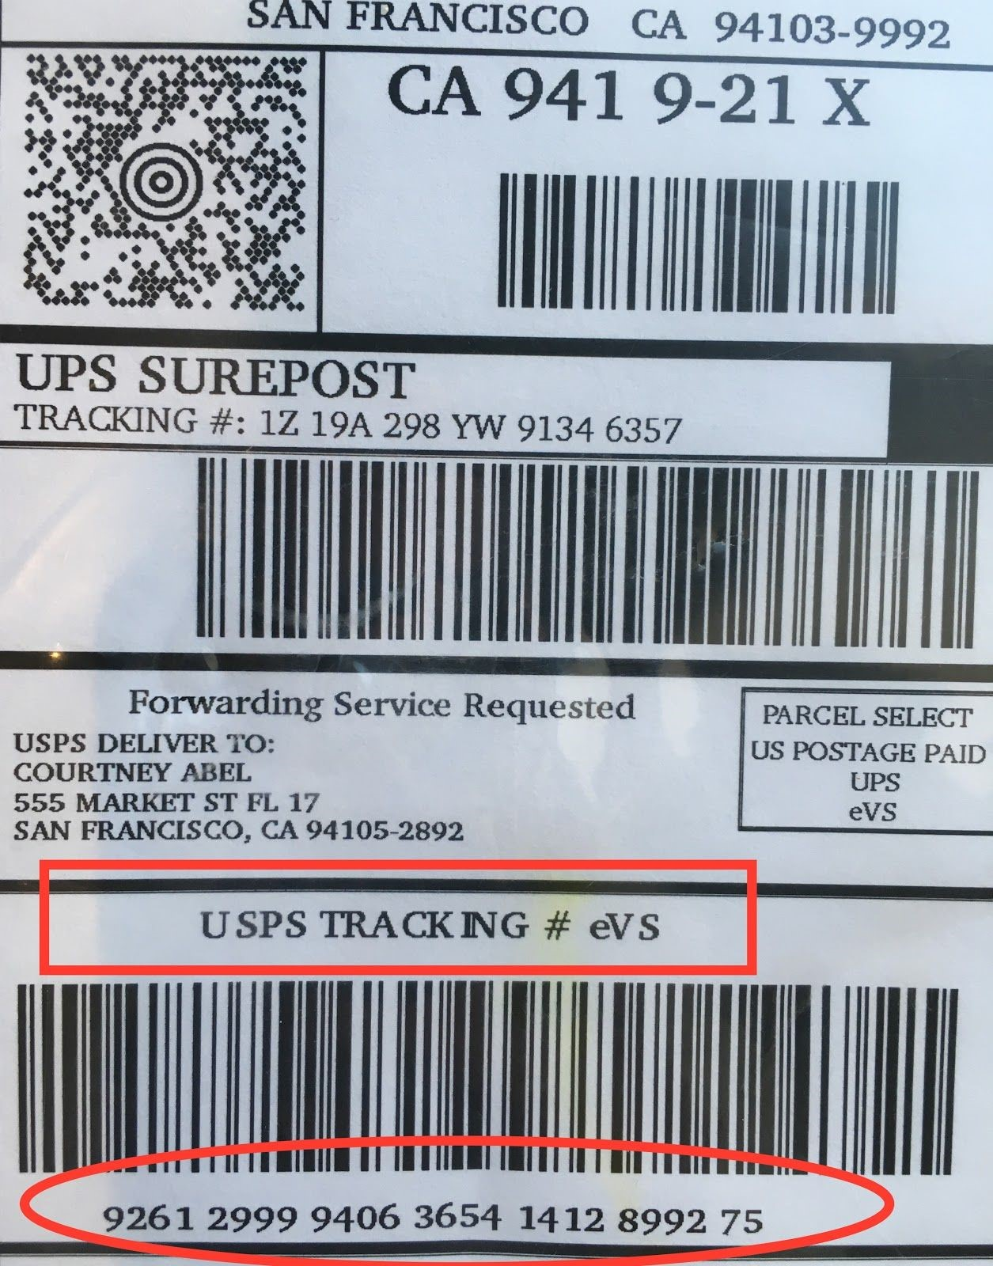

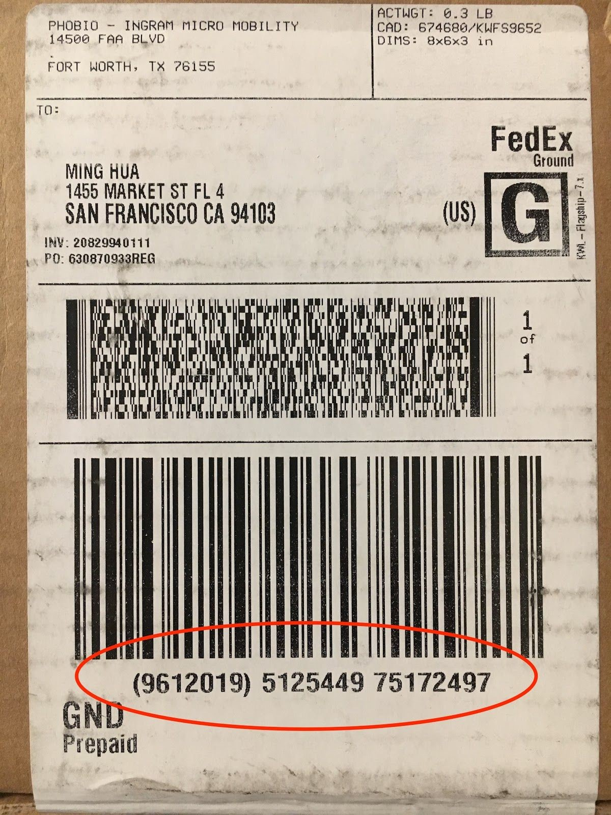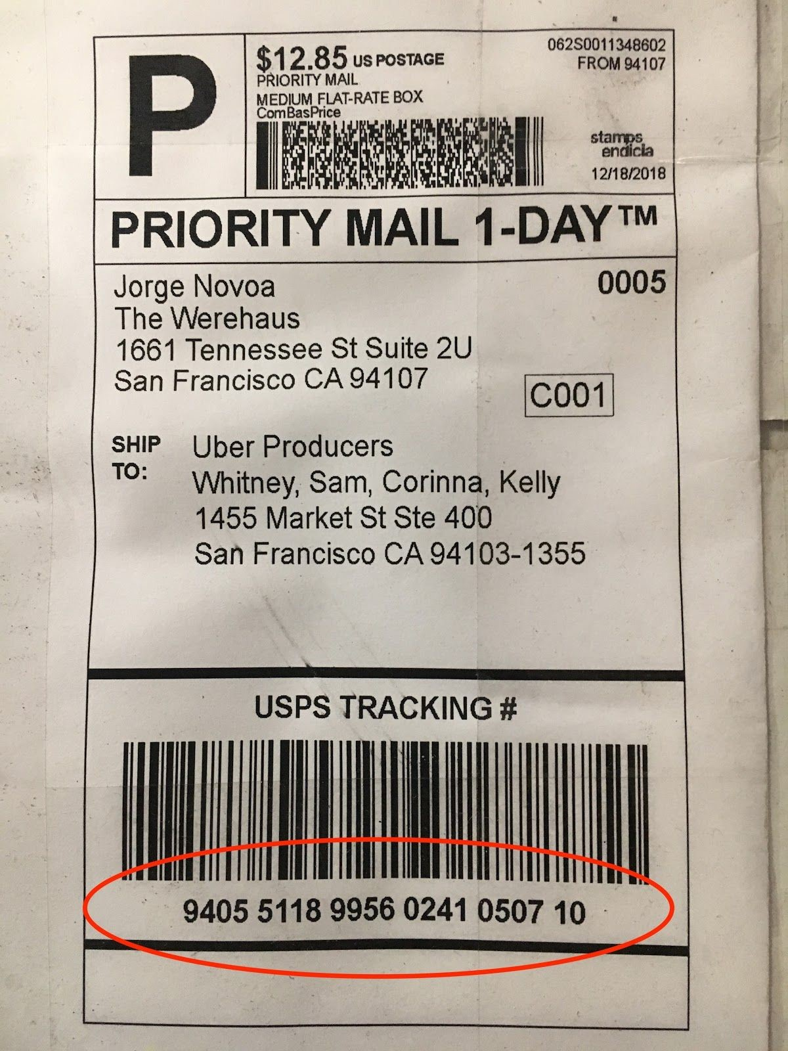

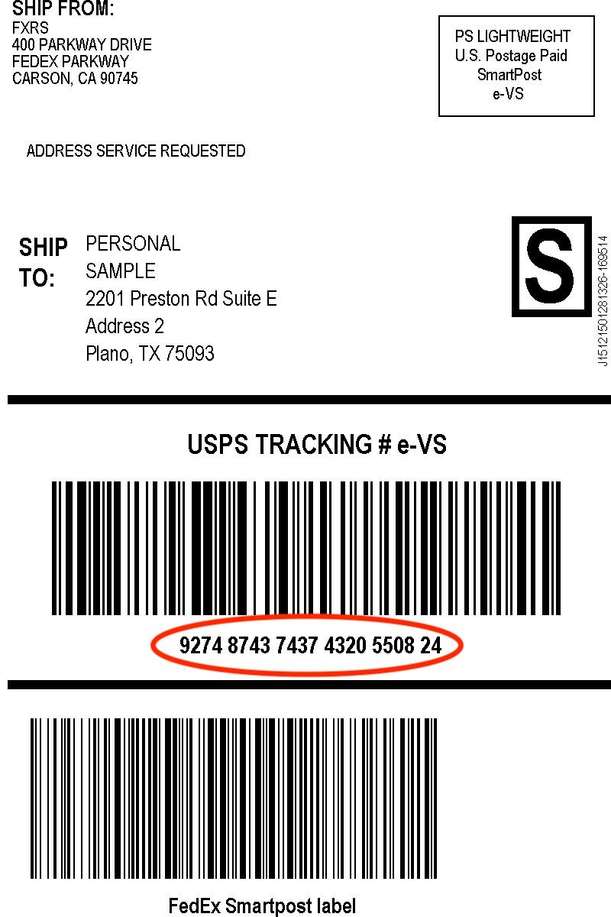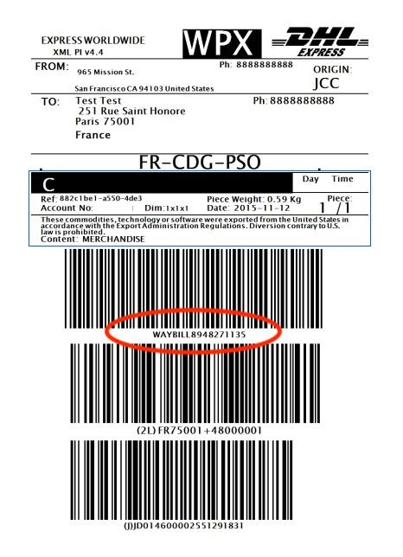

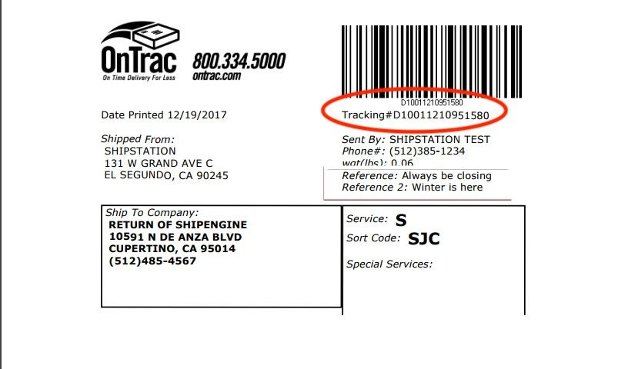
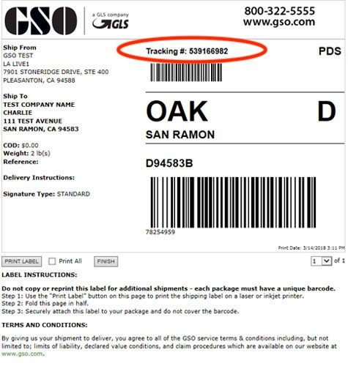
- Tracking number will populate within the field.
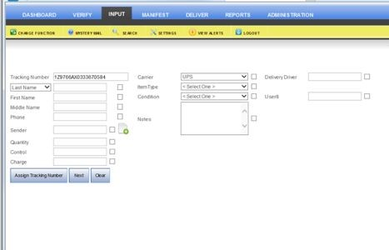
- In the Last Name field, type in the last name of the recipient on the package that was scanned.
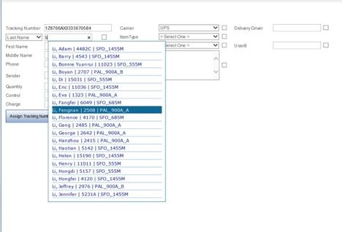
- A drop-down list will appear with all the names associated with that last name. Choose the name that matches the shipping label on the package. If there are too many searches under the last name, use a comma and start typing the first name to narrow the search or search by first name.
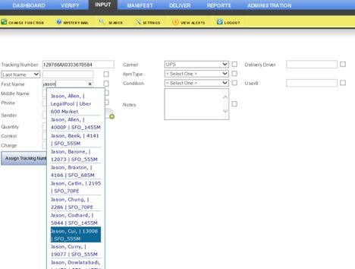
- After selecting the correct name, click on the arrow on the Carrier Field to select the name of the Courier Company that delivered the package. Use the condition field and select appropriate condition. In the Notes field, use this space to notate whether there is possible damage, if the box was opened upon delivery, if the package is leaking, or any other note pertaining to the package upon delivery.
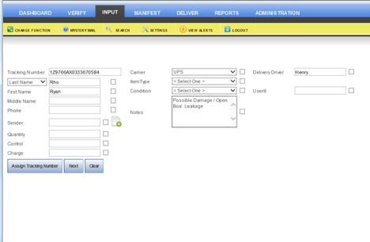
- Make note of the delivery driver’s name. This is part of the security protocol log that needs to be done. All courier driver’s must sign in. If it’s a new driver, we must get a copy of their work badge (if any.)
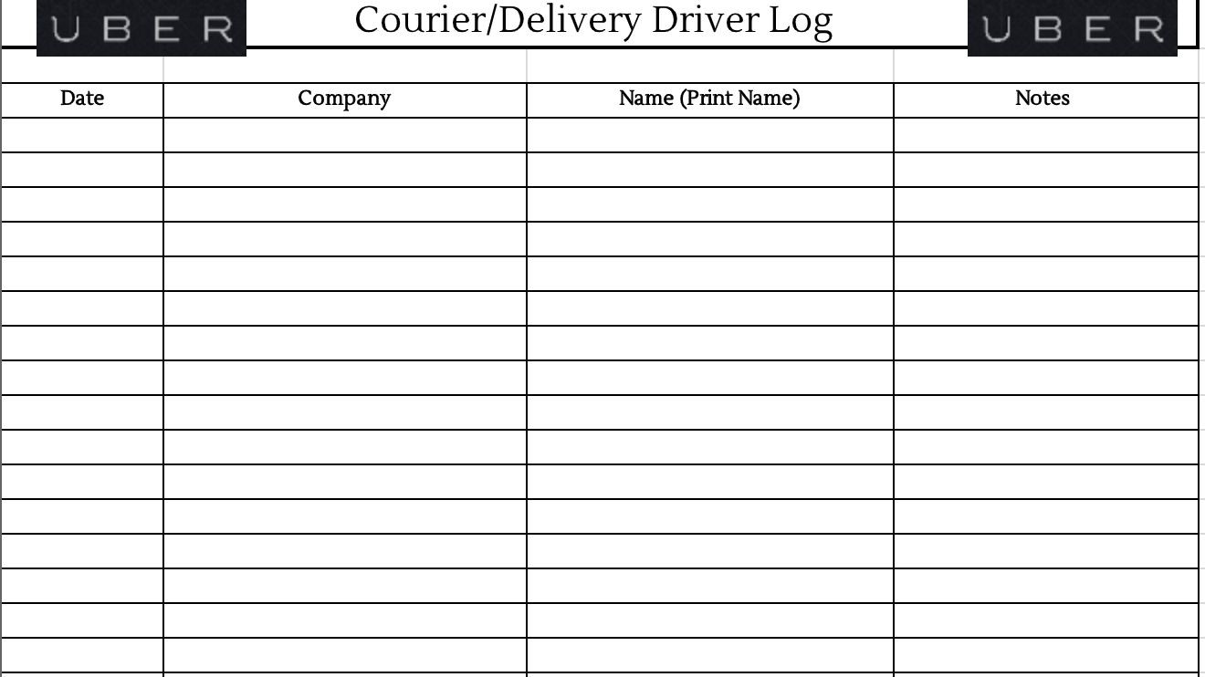
  - If they are a regular driver, just make a note of their name in the “Delivery Driver” Field.
- Once all the necessary fields have been completed and you have double-checked and verified that the correct name has been chosen with the name addressed on the label, click the Next button to print the label.
  - If you accidentally scanned it to a different person and rescanned it to the correct person, ALWAYS make sure to follow up and email the first person contacted that they do not have a package and that it was a mistake. Make sure to cc: the mailroom on the email as well so that they are aware.
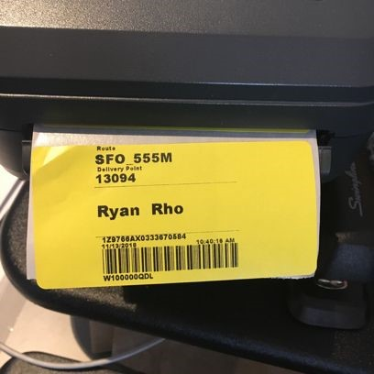
- Apply the label to the part of the package that will easily be accessible for delivery.
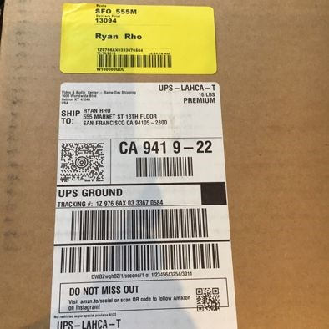
- Place the scanned packages with labels onto the appropriate shelf for easy access. Use bins to place flat and small packages in to avoid losing packages.
- If items received do not have a barcode/tracking number, manually create tracking numbers for items such as flowers, food deliveries, high-value package without barcodes, laptops from IT, pallet(s) of items.
  - Manual tracking number format: ItemDate (item - mm/dd/year), if multiple items, use ItemDate01 or ItemDate02.
  - Example: Flowers01032019, Flowers0103201901, Flowers 0103201902, ITLaptopPallet010319, 2AmazonBoxes010319 (boxes w/o tracking#)
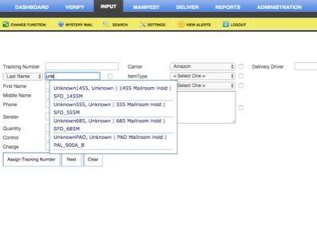
- If the name on the package does not appear in the system, use Unknown (mailroom) in the Last Name field. In the notes, put the shipper information in the field. In the NIS (Not in System) field put the name of the person that the package is addressed to. Once the label is printed, apply to package. Check HR TECH to make see if there is any contact information and send them an email using the “In HR TECH, Not in System” template. Make sure that the recipients are sent the Cold Package follow up emails after 14, 21 and 30 days. Input package information into the spreadsheet and place the packages on the Not in System shelf.
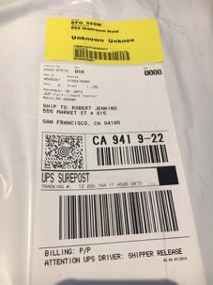

4. Ergo Equipment
Purpose:
To ensure the proper handling of Ergo equipment and eliminate misdelivery.
Procedure:
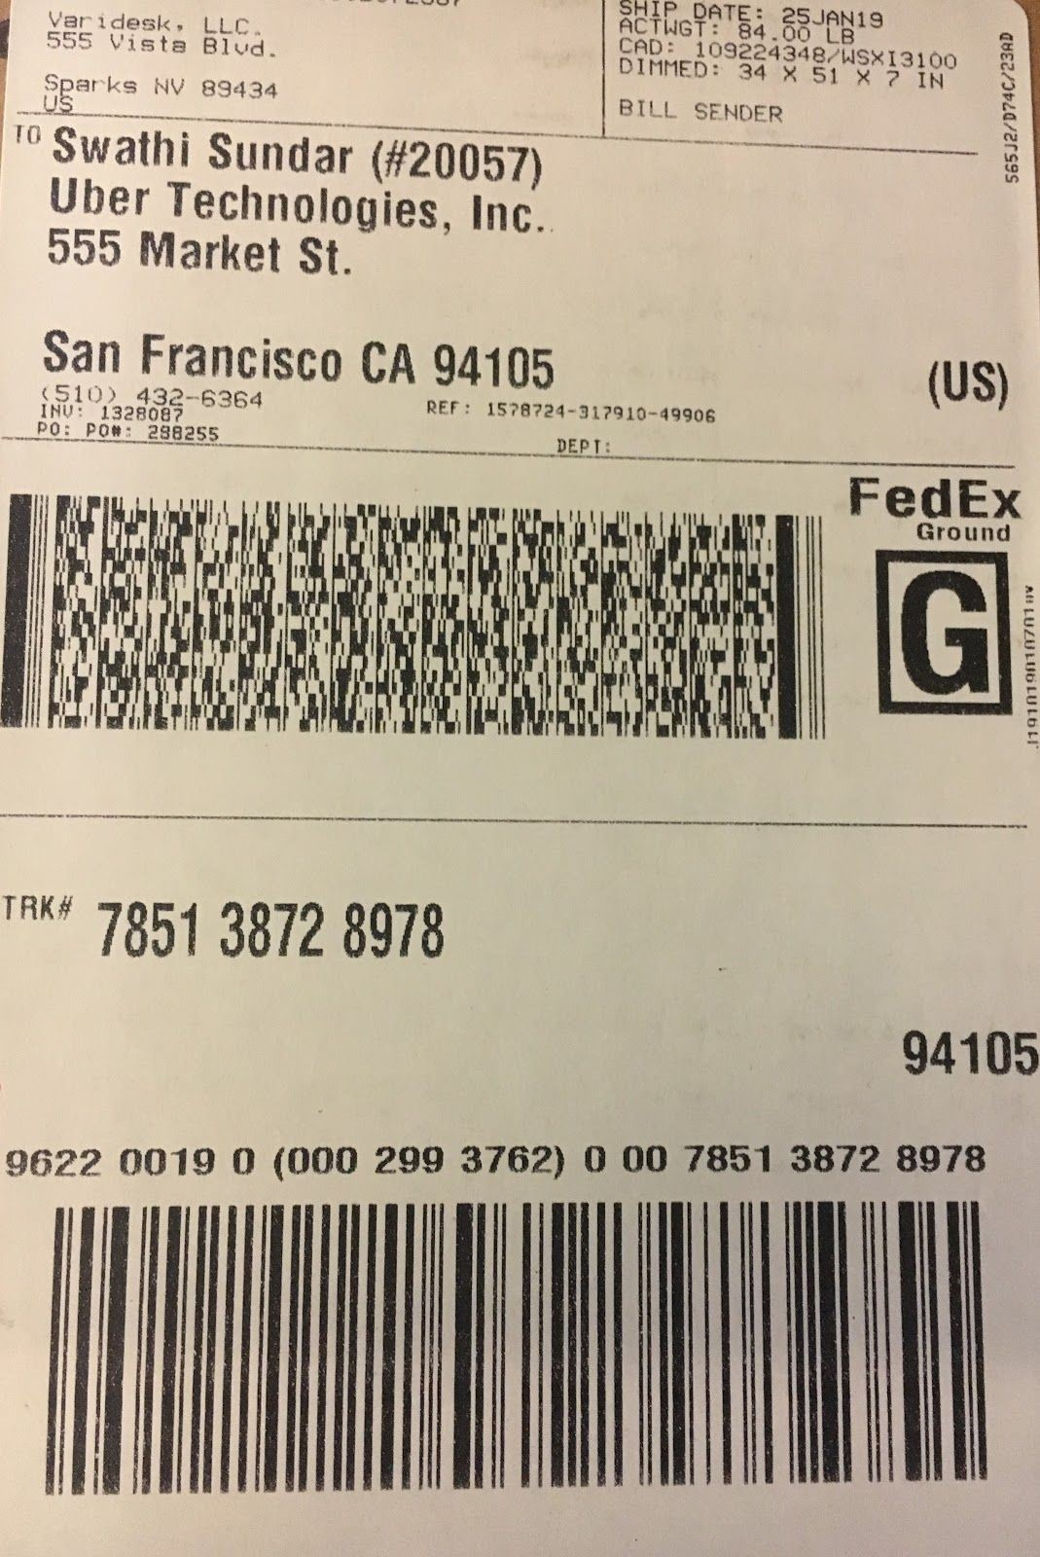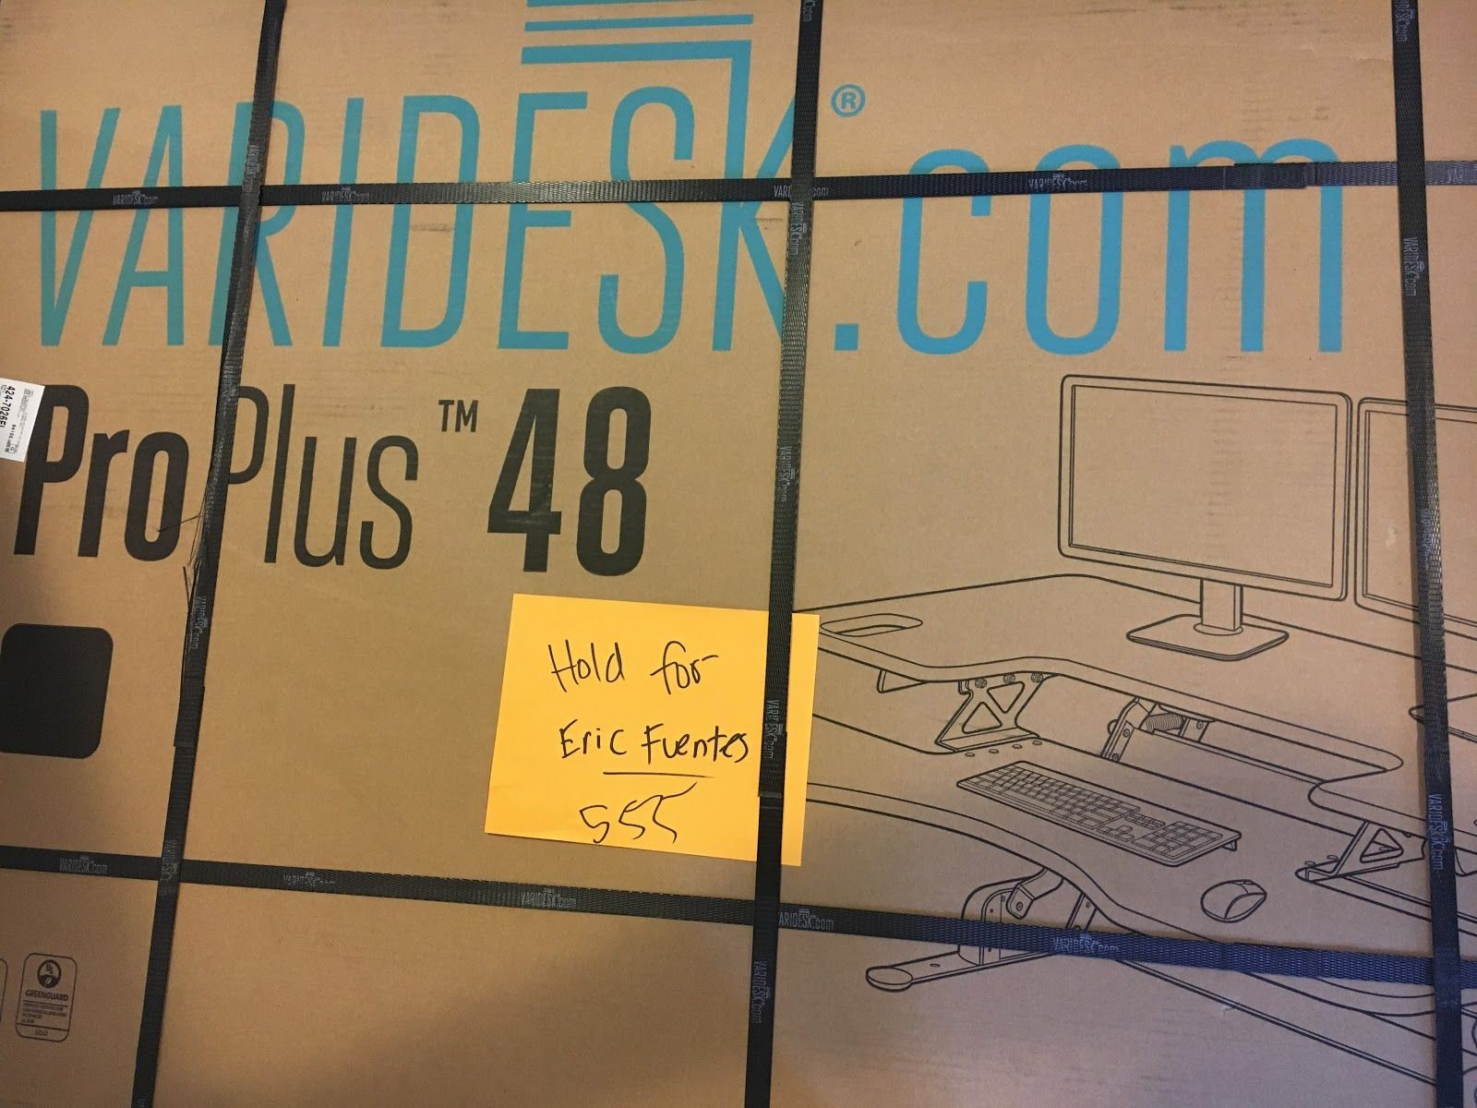
- Varidesks.
  - Varidesks will arrive with employee names. These packages must be scanned in
XXX to NAME so that he will receive the emails regarding its arrival. 1.2. Please email him with the employee name(s).
1.3. After scanning and placing XXX label on package, deliver to the designated Ergo storage area for each building (1455 - Field of Dreams, 685 - 7th Floor Storage & 555 - Basement Storage/Pending access.)
- Ergonomic equipment such as Quick Stands or shipped from Humanscale (with the exception of Keyboard Trays) addressed to either NAME or NAME: 2.1. Must be scanned in XXX to NAME and placed in the designated Ergo storage area for each building.
2.2. DO NOT INTEROFFICE unless instructed otherwise.
- Miscellaneous ergonomic equipment.
  - Keyboard trays, footrests, seat cushion pads, standing matts, gel wrist pads, microsoft keyboard and computer mouse ordered through Amazon.
  - Please scan into XXX and deliver to employee as usual.

5. IT Equipment (CDW specific)
Purpose:
To ensure proper handling and delivery of CDW packages for IT.
Procedure:
- All packages with a tracking number MUST be scanned. If it does not contain a barcode, create one. See Inbound 14.1 & 14.2 for examples.
- If the packages are addressed to FOD (Field of Dreams), inbound scan to Angelo Espinosa via XXX and deliver to the Field of Dreams Basement Cage (make sure to put this information in notes).
- If the packages are specific to IT Supply Chain 4th Floor, inbound scan to Laura Shannon and deliver to IT Bar on the 4th Floor.
- If we receive packages going to NAME, inbound to NAME and place in the field of dreams separate from the other shipments. Make sure that they are not mixed with the other.
- If we receive packages going to other people associated with the IT Department (such as NAME), inbound scan to that person so that they receive an email that it has been received and inquire where they would like the shipment to be delivered.

6. Miscellaneous Packages
Purpose:
To ensure certain packages of special circumstances are directed efficiently and avoid overhandling the packages through interoffice.
Procedure:
- SWAG and clothing coming in bulk that are addressed to employees located in other buildings other than where it was received, should be contacted to make sure that it is not intended for a specific person for an event. This will prevent transferring packages back and forth unnecessarily.
  - One way to identify swag is by checking the packing list or if there are any stickers/labels on the box with a list of sizes and quantity of clothing. It is most likely swag/clothing.
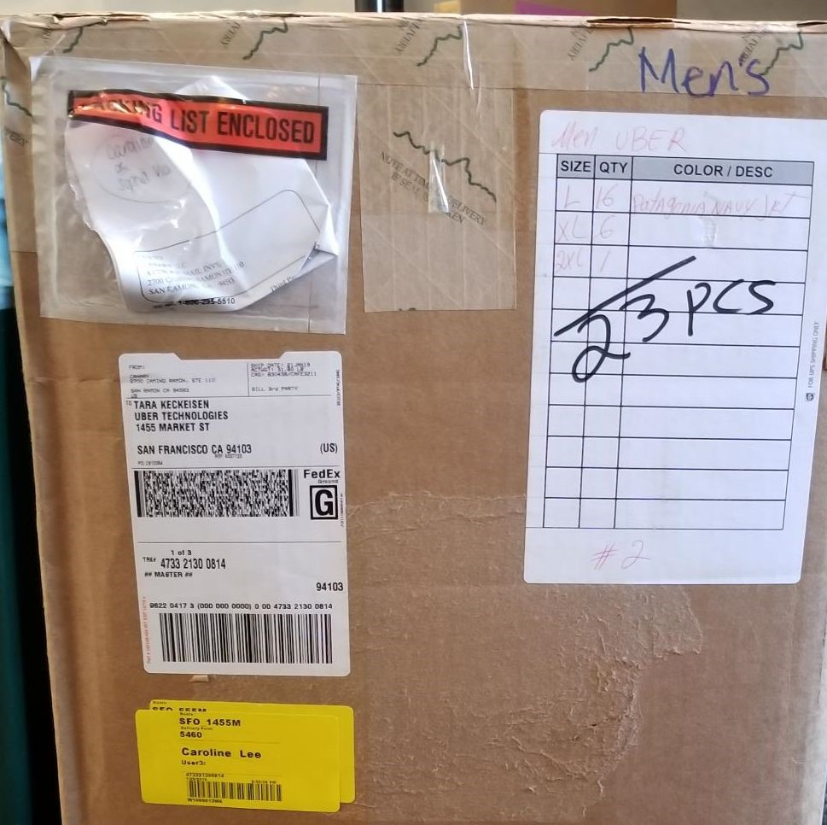
- Facilities (Site Support) - Office Supplies coming from Staples, usually go to facilities. If ordered through Coupa, there is a tendency for the recipient’s name not to be included on the shipping label.
  - HQ - If coming from U-Line or Staples, reach out to NAME or NAME for verification.
  - EXT - Scan into XXX under NAME & deliver to the 10th Floor Storage.
  - EXT - Scan into XXX under NAME & deliver to 3. Janitorial - Janitorial Supplies.
  - HQ - Scan into XXX under NAME & deliver to the Field of Dreams.
  - EXT - Scan into XXX under NAME & deliver to the 10th Floor Storage
  - EXT - Scan into XXX under NAME & deliver to

7. Mail Sorting
Purpose:
To properly distribute mail received to the appropriate department and person of contact.
Procedure:
- Sort mail in the labelled bins.
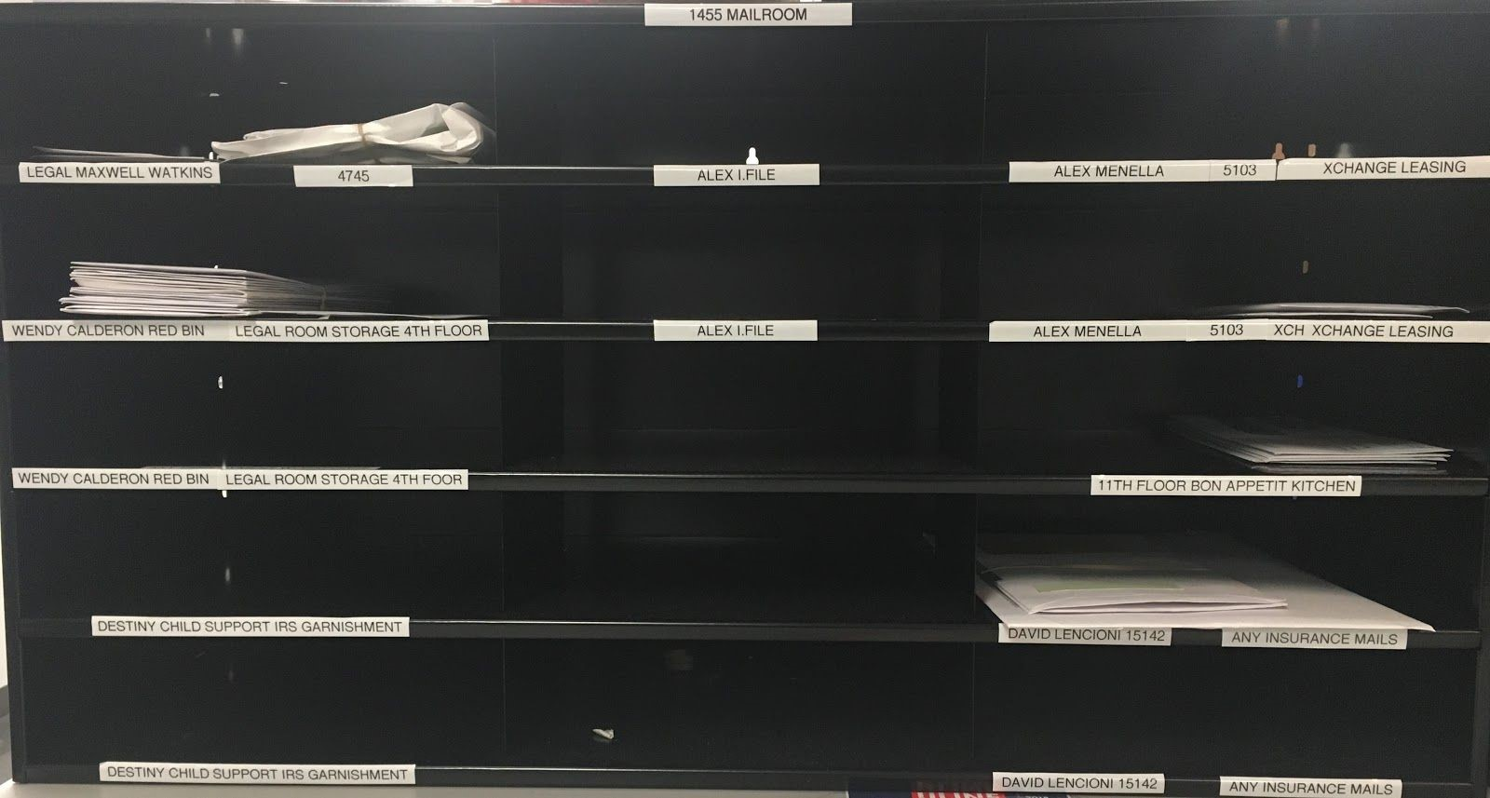
- Please note the following departments and point of contact:
  - All Legal mail including claims, accidents & injury lawsuits go to XXX (Desk# 4748.)
  - All Workers Compensation mail will got to XXX (Desk #4753.)
  - All mail from the Department of Labor or any employment workforce go to XXX (Legal Room Storage on the 4th Floor.) 2.4. Mail for Xchange Leasing (Central Ops) go to XXX
  - All mail for XXX go to the 11th Floor.
  - All Insurance mail go to XXX.
  - All mail regarding Child Support, Family Support, IRS, Garnishment, EDD, etc. go to Destiny Hamilton.
  - Any HR related mail go to XXX (Desk #9031) at STREET-NAME
Street.
  - All mail or packages for Cash Management or addressed to XXX, please forward to XXX at 685 (Desk# 9004.) 2.10. All tax related mail and mail addressed to XXX go to
(Desk# 6131) at STREET-NAME.
2.10.1. If the ship from address has anything that has “tax,” “Department of Revenue,” or City of …,” should go to XXX.
  - All XXX Mail involving garnishments will go to XXX, everything else will go to XXX at 1455 (Desk #4742)
  - All Accounts Receivable goes to XXX (Desk# 8140) at STREET-NAME. All checks will go to XXX (Desk# 8143 starting DATE)
  - All Accounts Payable (Checks, Checks Returned to CLIENT or from CLIENT, 1099’s, W-9’s, Bills & Invoices) goes to XXX (Desk #6119) at STREET-NAME.
  - All Payroll mail goes to NAME (Desk# 8151) at STREETNAME.
  - All Bank related Mail without names go to NAME (Desk#
9016) at STREET-NAME.
  - All CLIENT Freight mail and checks go to NAME (Desk# 8143) at STREET-NAME.
  - All Immigration mail or mail addressed to NAME goes to NAME at STREET-NAME (Desk# 9061)
  - All mail for NAME shall go to NAME (Desk# 7098) while she is on maternity leave.
  - Mail for NAME from banks (ie. JP Morgan Chase Bank, N.A.) regarding paper inquiries, bank chargeback, pre-arbitration and other disputes can be shredded going forward per NAME. When in doubt, refer to NAME as POC.
- Please note following VIPs (EAs subject to change).
  - All mail for NAME goes to NAME
  - All mail for NAME (4008) go to NAME.
  - All mail for NAME (4003) go to NAME.
  - All mail for NAME go to NAME.
  - All mail for NAME (4315) go to NAME.
  - All mail for NAME (14001) go to NAME.
  - All Mail for NAME (15100) go to NAME.
  - All Mail for NAME go to NAME.
  - All Mail for NAME (4002) go to NAME.
  - All Mail for NAME (4638) go to NAME. 3.11. All Mail for NAME (4007) go to NAME.
3.12. All Mail for NAME (4705) go to NAME.
- Certified Mail & other trackable envelopes from FedEx, UPS, etc.
  - Make sure all certified mail and all trackable envelopes are scanned via XXX. Remember all trackable packages MUST be scanned into the XXX system to show receipt and end delivery information.
- For a more detailed list of who receives what kind of mail, click on the following link:

8. Delivery
Purpose:
To ensure proper delivery of packages to customers by capturing signatures, taking photos of where the packages were delivered to and using the notes field for pertinent delivery information, eliminating loss of packages.
Procedure:
- Using the scanner, go to the home screen. Make sure the scanner is signed in under your name and not any other user.
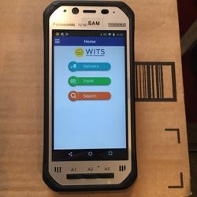
- Click on the Delivery option located at the top of the screen.
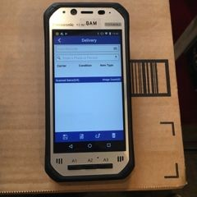
- The Delivery Screen will appear.
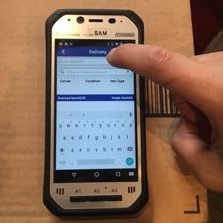
- During delivery, if there is a person sitting in the desk, ALWAYS ask them if they are the person who that package is being delivered to. Click on the Scan Barcode Field and scan the yellow WITS label that was printed and placed on the package.
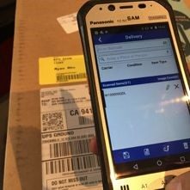
- Once the yellow barcode has been scanned, it will appear in the field below underneath Scanned Items. Make sure to verify that the Yellow XXX Label # matches the one on the scanner. If there is more than one package, continue to scan every package going to the same person until they have all been accounted for on the scanner.
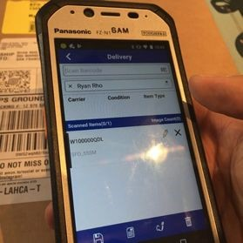
- Once you have completed scanning all packages, click on the signature icon to obtain Customer’s signature and make sure to click the save icon to save the delivery transaction.
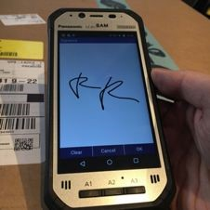
- If the person at the desk is not the person you are trying to deliver to, ALWAYS ask them if they know the person that you are trying to deliver the package to.
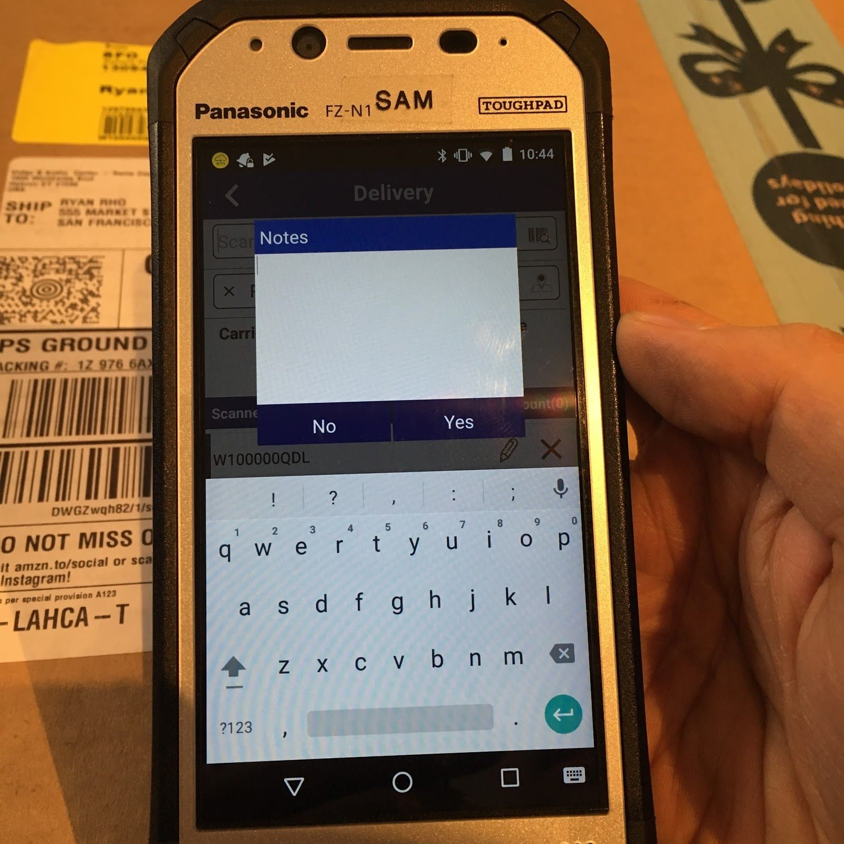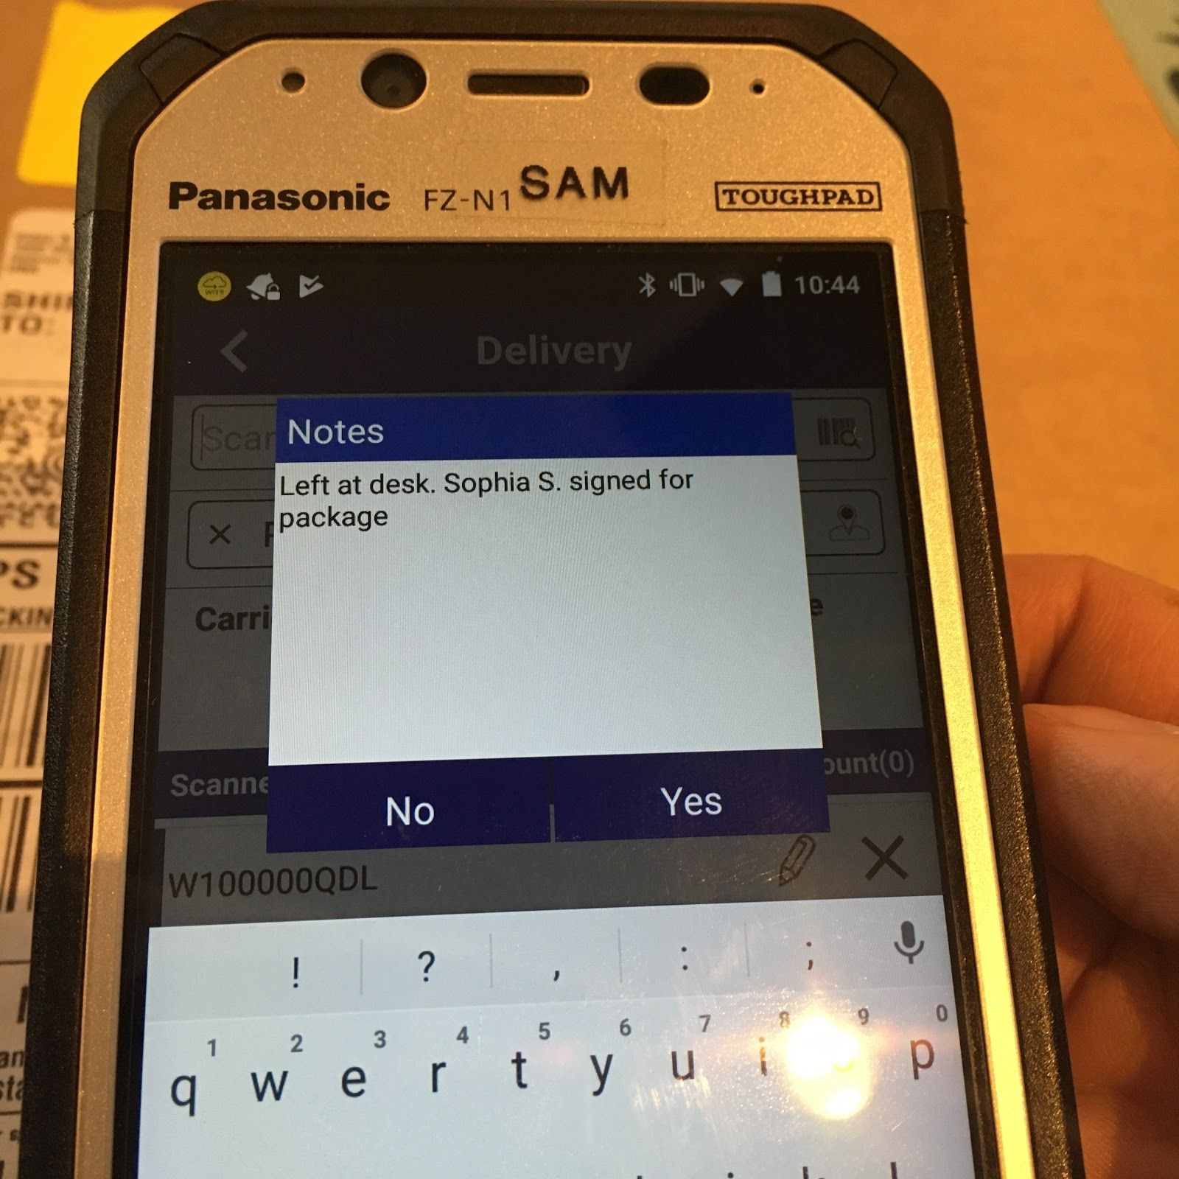
  - If they know the person that you are trying to deliver to, ALWAYS ask if they would mind signing for the package and get their signature. Make sure to click on the notes icon after obtaining the information and notate the name of the person who signed for the package and their desk number. It is very important that we put this in notes so that if the recipient comes to inquire about it, we have the name of the person who signed for it and be able to provide it as a reference when they ask for it. Take a picture of the package with the desk number as proof of delivery and click the save button to save the transaction.
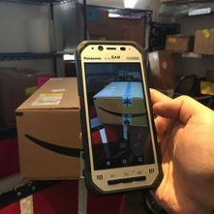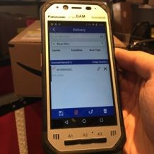
  - If they do not know the person or you have never seen the person before, just bring the package back at the mailroom. It is better to be safe and make sure that the package does not go missing. The customers desks are always moving.
  - If the person tells you that they sit at a different desk and provides you that number, you can go to the new desk to check if they are there, if not, just bring back the package to the mailroom and send them an email verifying the desk number for confirmation.
  - If you are 100% sure that the person sits there, always take a picture of the package with the desk number. A paperclip will appear next to the XXX Label ID.
  - If you are not sure that they sit there, bring it back to the mailroom.
- For packages/envelopes going to VIPs, ALWAYS send to the Executive Assistants, NEVER directly to the VIP. Please refer to the list attached. Reminder this list may change. Update accordingly.
- All packages for VIPs and EAs - Must be delivered same day. If they are not available, please contact them via email to inform them that they have a package even though XXX has already sent them an email. They will assume that it would be delivered.
- Flowers, Food & Perishable Goods - As soon as these deliveries are received and scanned into XXX, these need to be delivered same day. No exceptions. If they are not available, please contact them via email to inform them that the package is perishable.

9. Legal Mail Room (Locker delivery)
Purpose:
To ensure packages going to the lockers in the legal mailroom are properly processed.
Procedure:
- The Legal Mail Room is only accessible through those who have clearance.
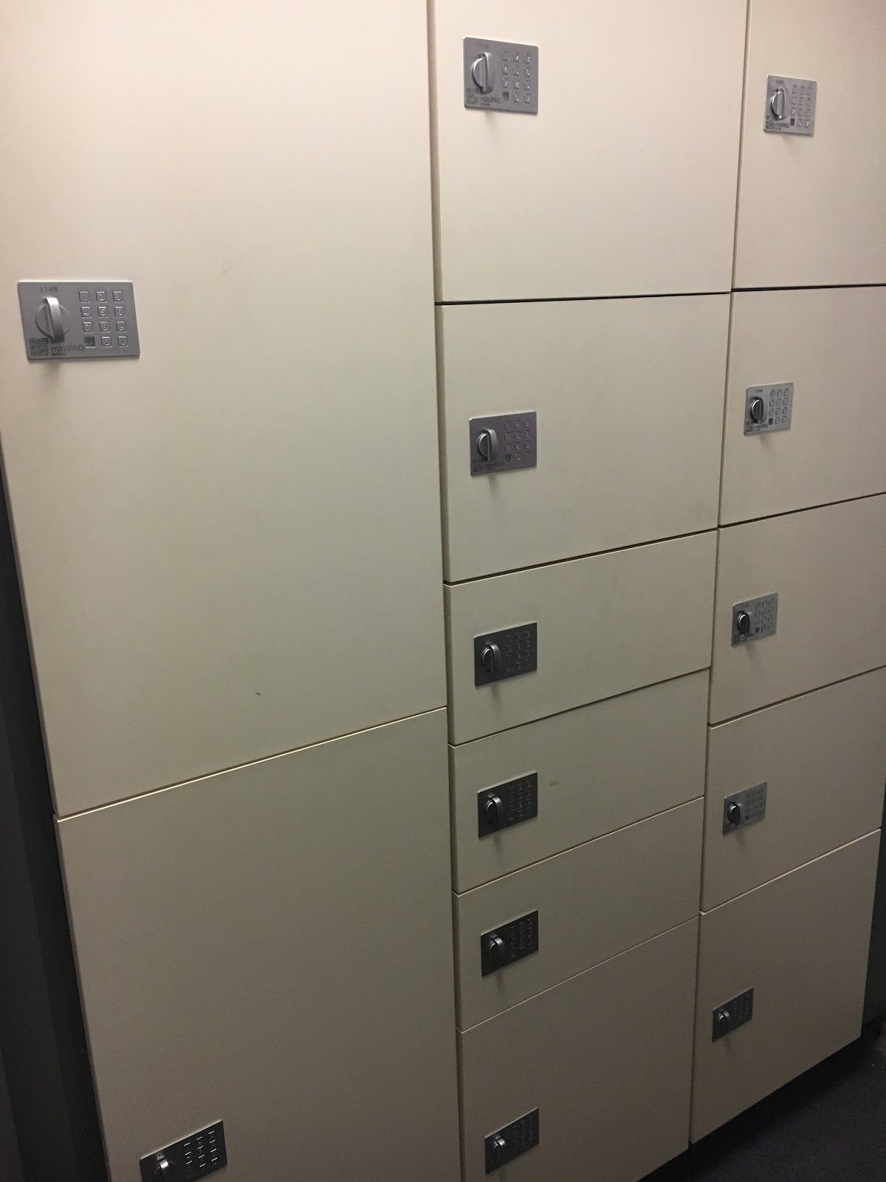
- Deliveries can only be made to lockers that have a flashing green light notifying you that is empty.
- Using the handheld XXX scanner, select the Locker Delivery option.
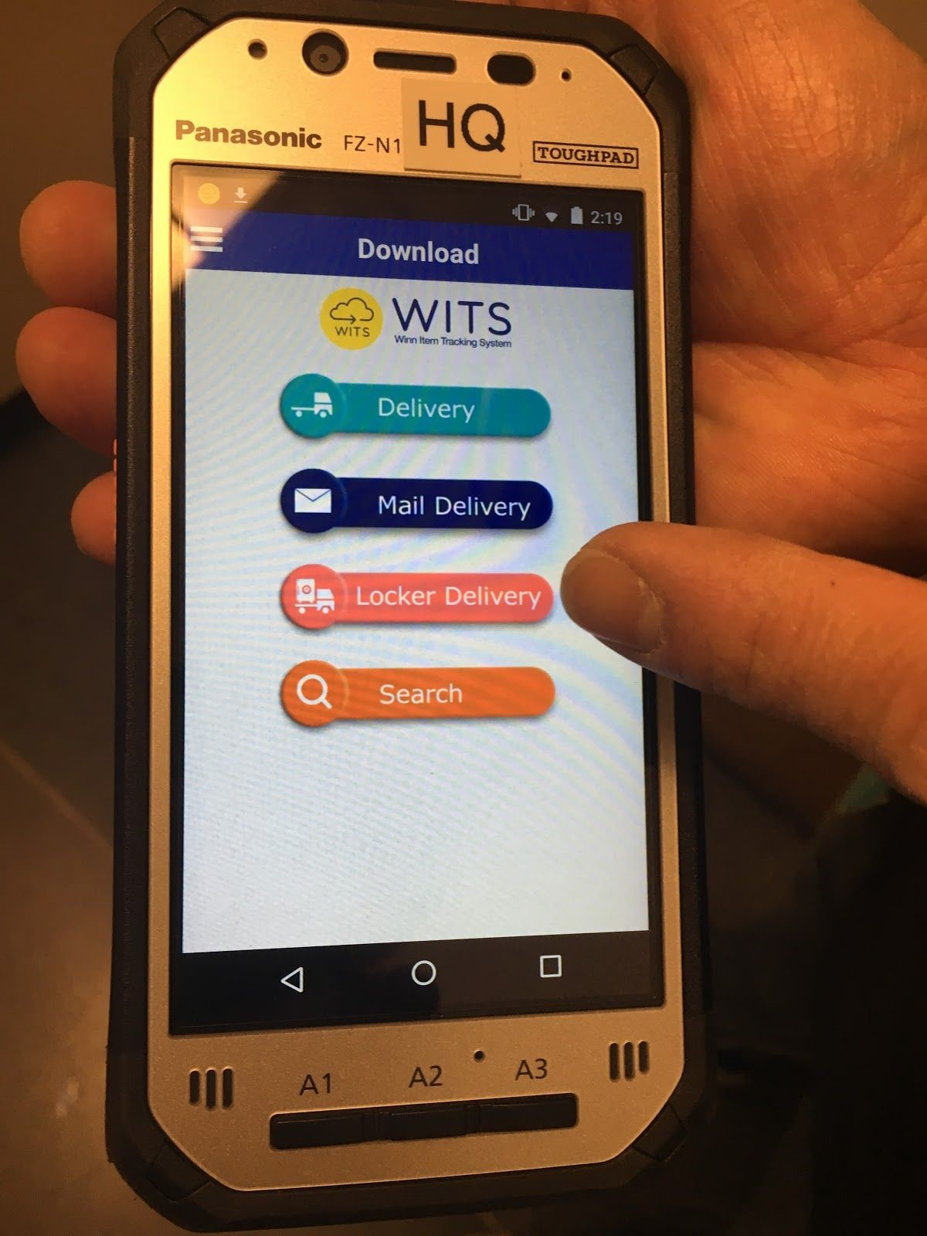
- Once in locker delivery mode, scan the XXX yellow barcode(s) to be delivered.
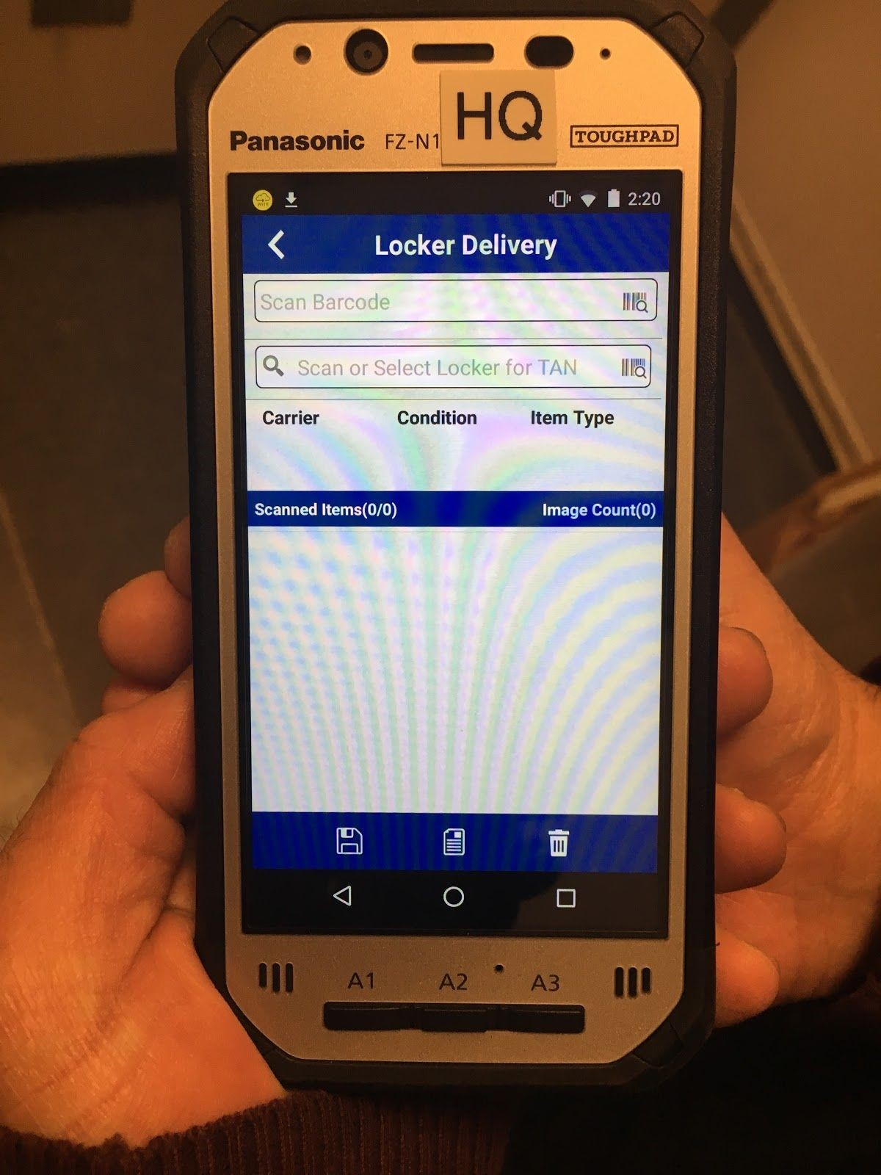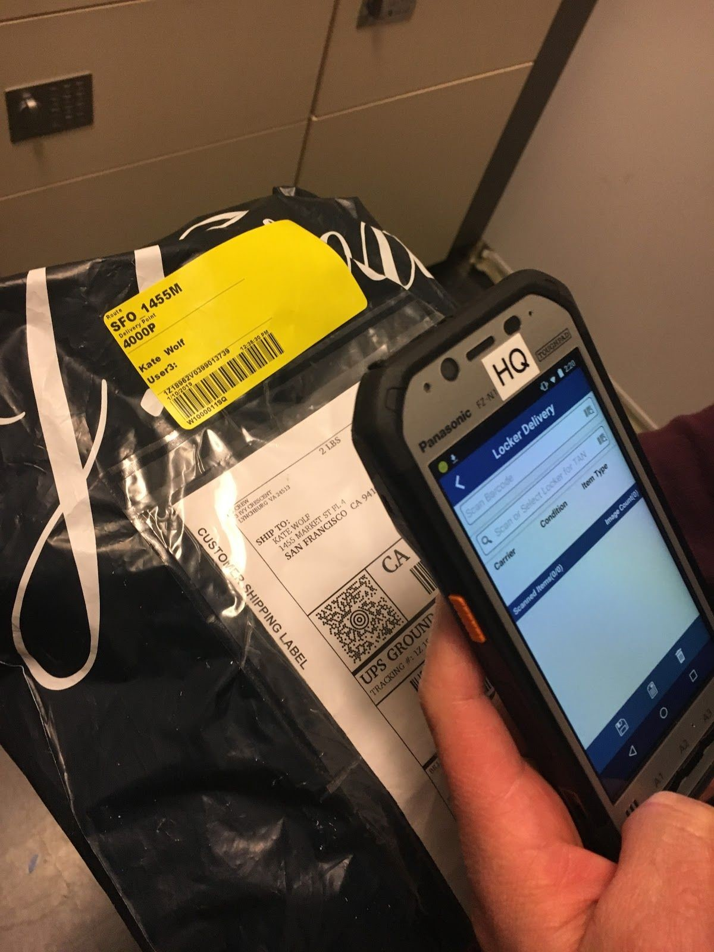
- Select the locker number to which the package(s) will be delivered to and the scanner will provide a code to enter to open the locker.
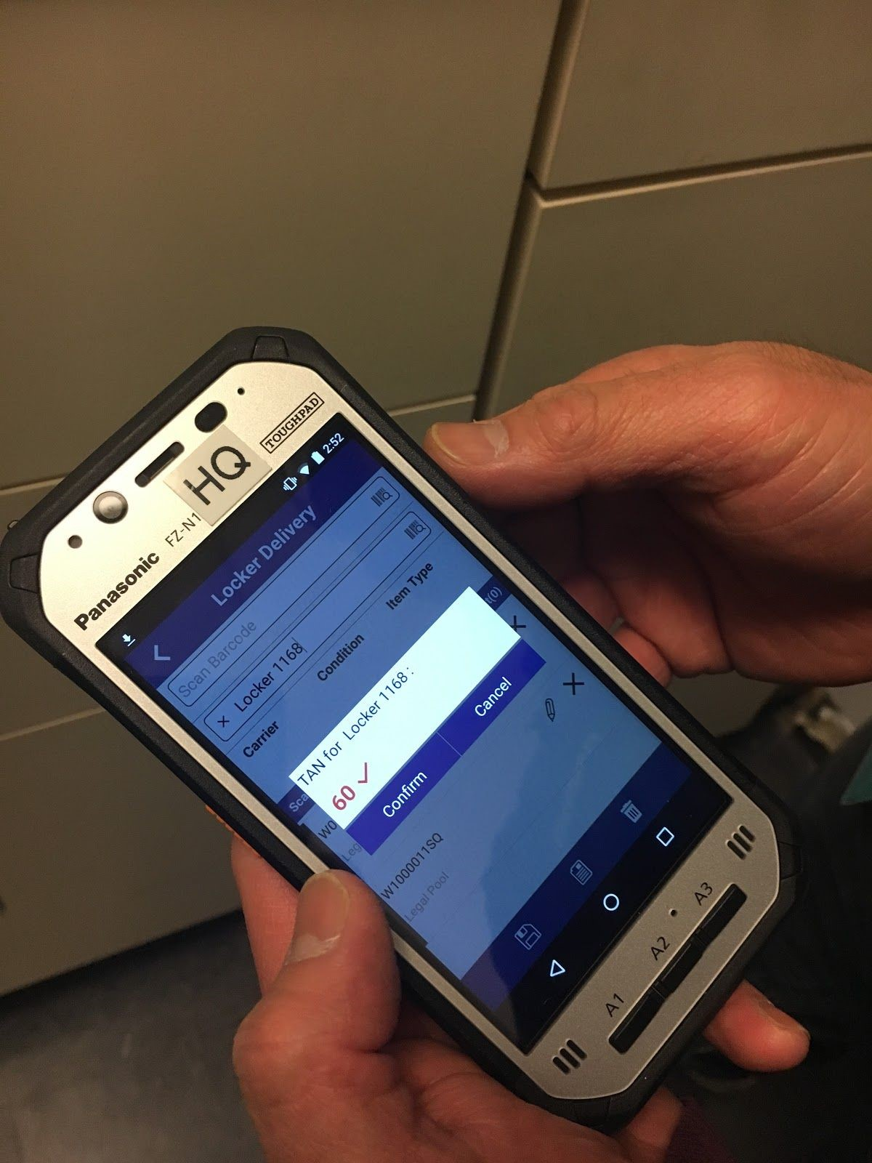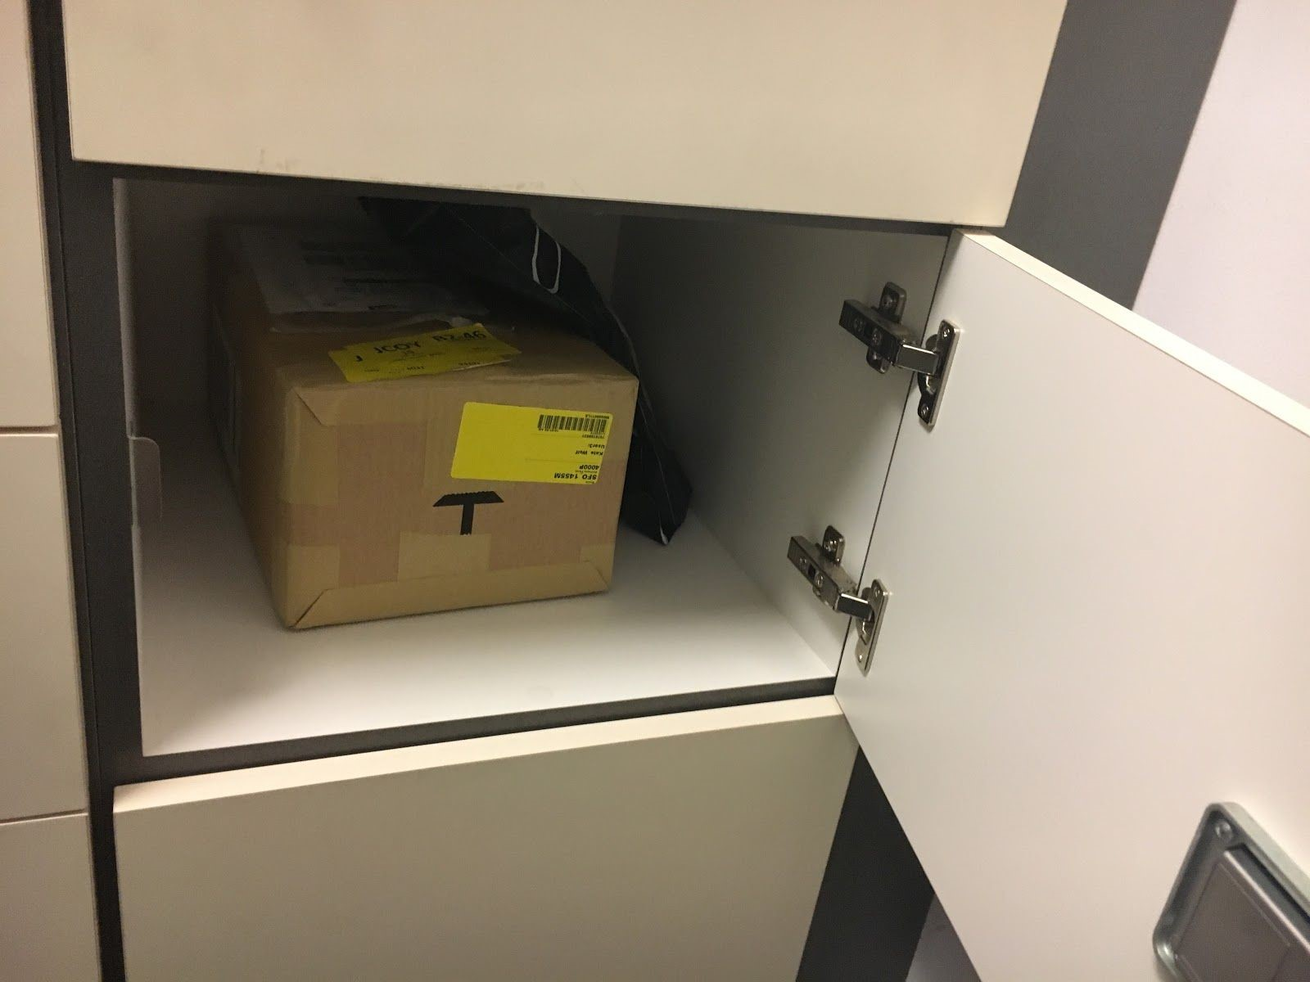

- Open the locker using the code that was provided and place the package(s) inside. DO NOT click Confirm until after closing the locker.

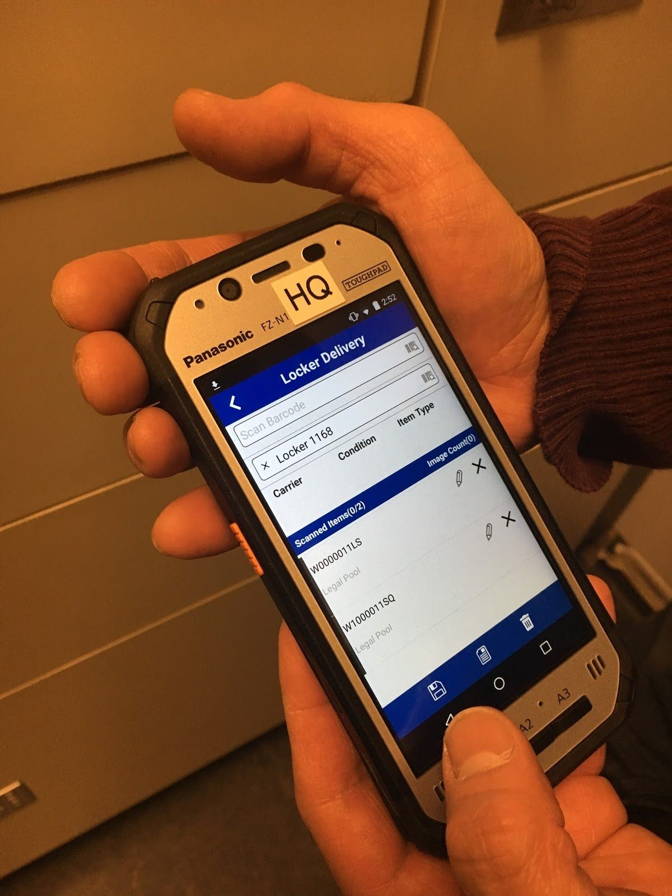

- After you have closed the locker. Click confirm and click on the save button at the bottom to save the transaction.

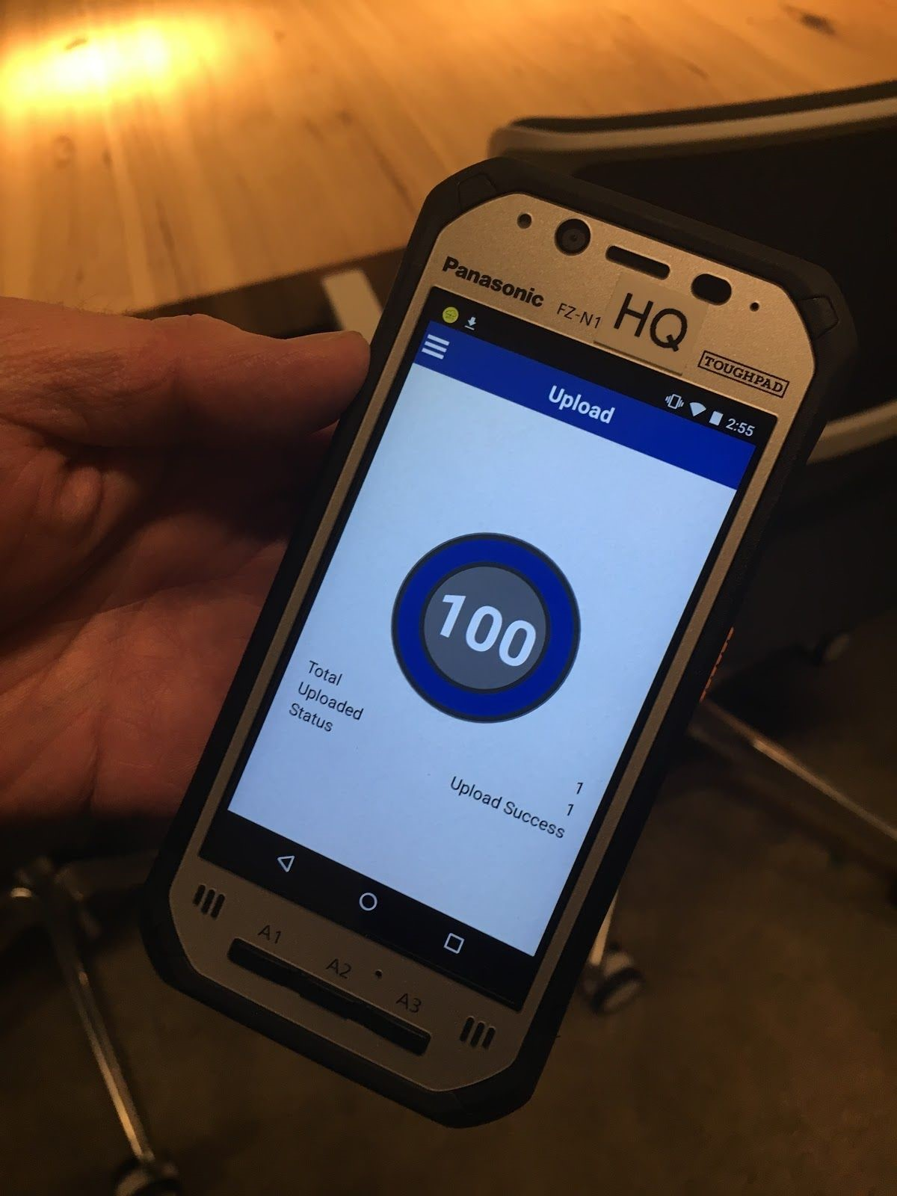

- Upload the transaction and upon completion the passcode will be sent to the customer via email.
- Please note​: There is a black device on the corner near the ceiling that point to the lockers. Make sure that the device is pointed towards the lockers so that it can scan the QR codes.
- ​Troubleshooting Tip:​ If the lockers are not opening or saving, it could be because the black device is not aimed at the lockers. Please make sure that this device is always pointed in the direction of the lockers.

10. Email Inquiries via mailroom@​ CLIENT.com
Purpose:
To respond to emails inquiring about packages promptly within an adequate time frame.
Procedure:
- All emails received via ​mailroom@CLIENT.com​, must be responded to within 5 minutes of receiving the email, letting them know that you have acknowledged their inquiry and that you will do some research.
  - Always ask for tracking number and any pertinent information needed to do the research, such as who the shipper is.
  - Make sure to ALWAYS reply all so that other team members are aware that you are in the process of researching the package.
- Use the tracking number to track the package via the courier’s website.
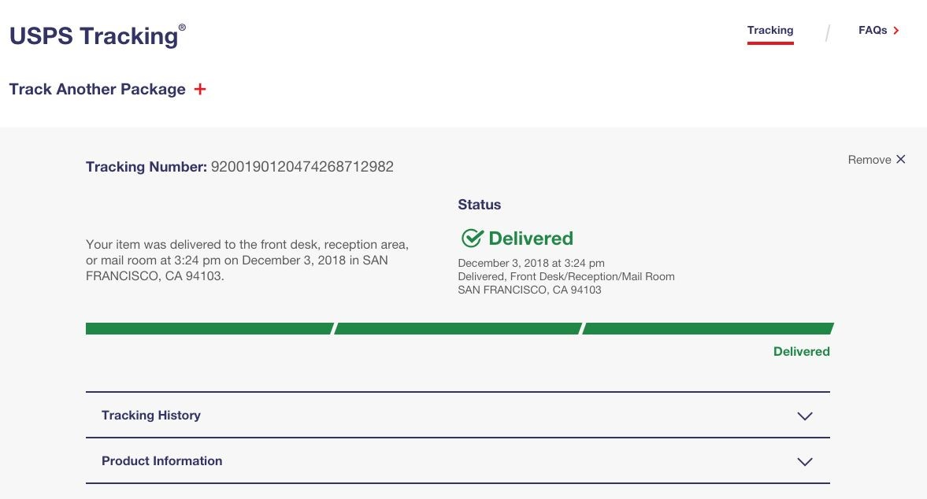
- Use XXX search option to track the package with the tracking number provided or using their name.
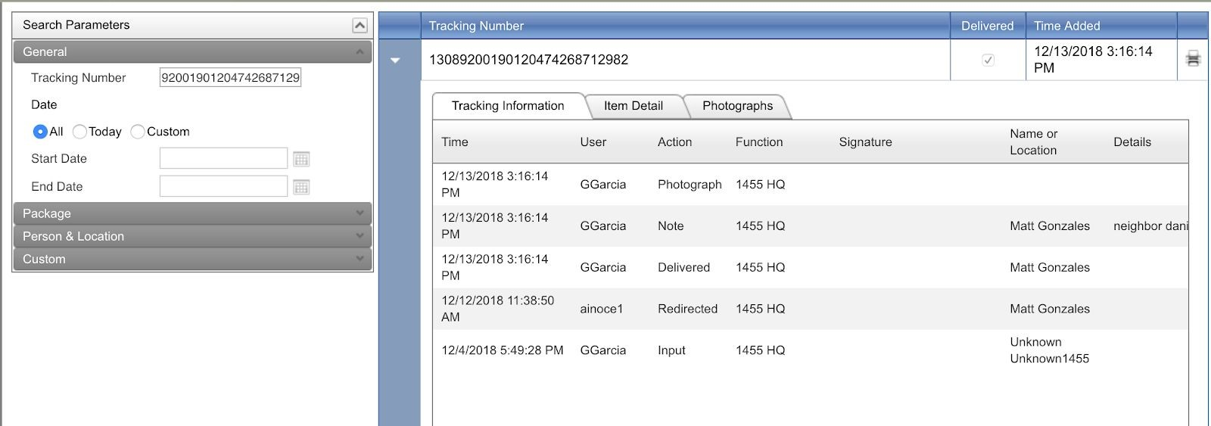

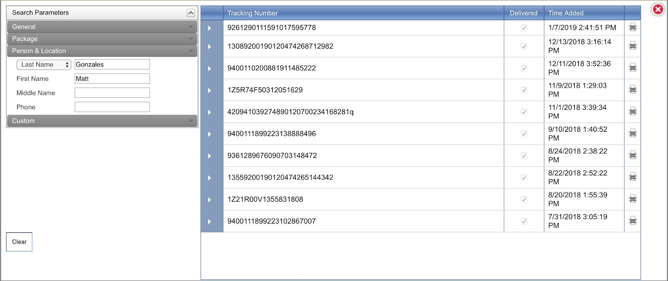

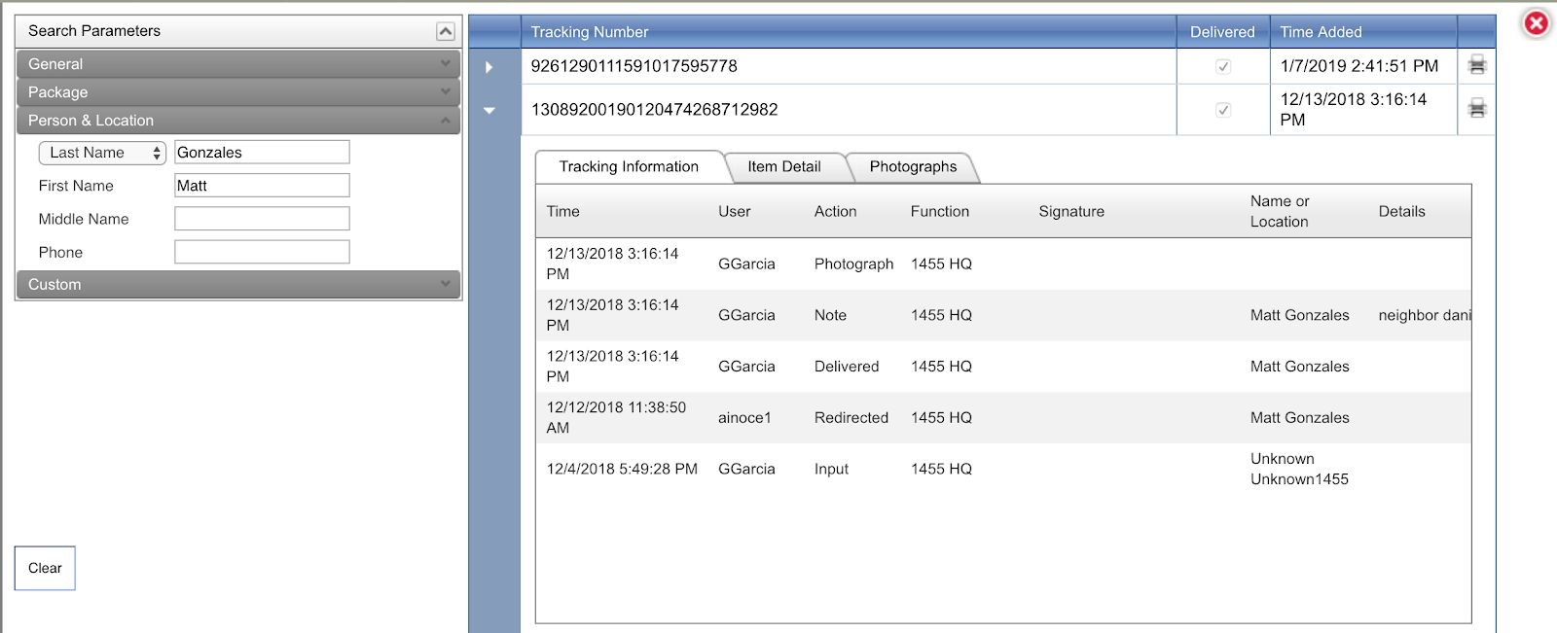

  - If something comes up, use the Tracking information tab to see who
scanned in the package, when and where the package was scanned, any notes regarding delivery such as the name of the person the package was indirect delivered to and pictures of where it was delivered.
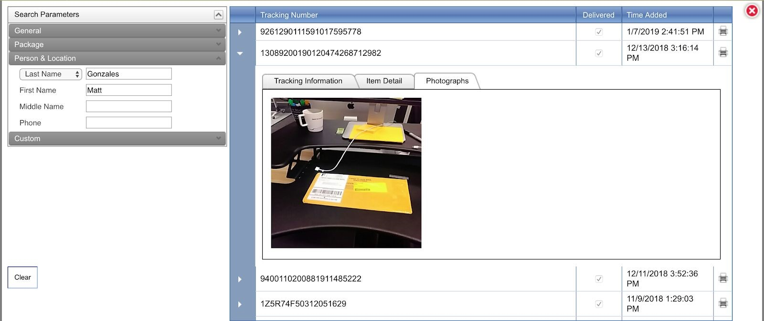
- Example Scenarios:
  - If package is found in the XXX system, but not delivered, check all shelves for package(s).
  - If package shows delivered and signed by one our mailroom staff, check all shelves for packages.
  - If package doesn’t show as delivered, have customer contact shipping courier and/or sender depending on the situation.
- The response time in resolving the issue should be within 10 minutes of acknowledgement. Make sure to let them know the situation and offer solutions.

11. Interoffice & Interoffice Vehicle
Purpose:
Process for interoffice transfer of packages/mail/equipment between all SF Facilities and Palo Alto.
Procedure:
- When preparing the interoffice transfers of all packages, envelopes and/or equipment, use XXX to prepare a yellow internal tracking label.
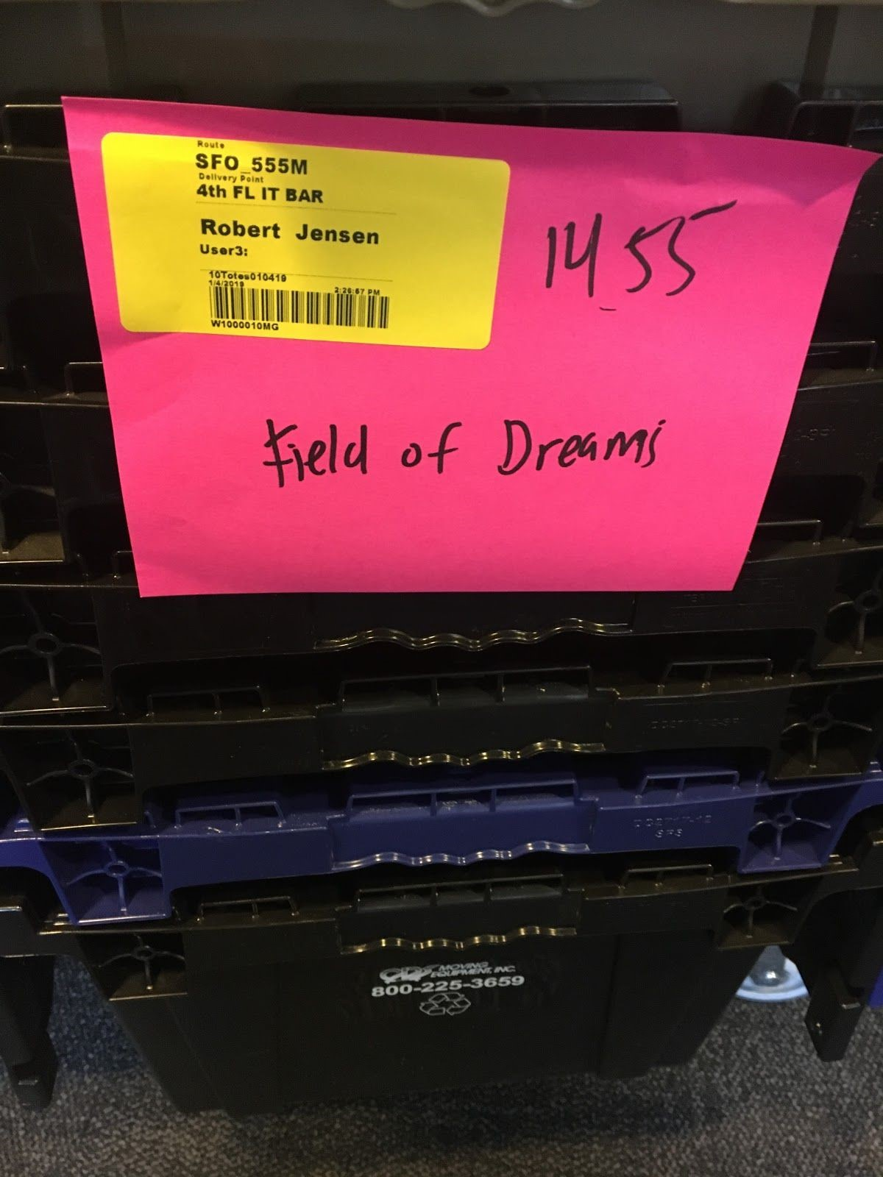
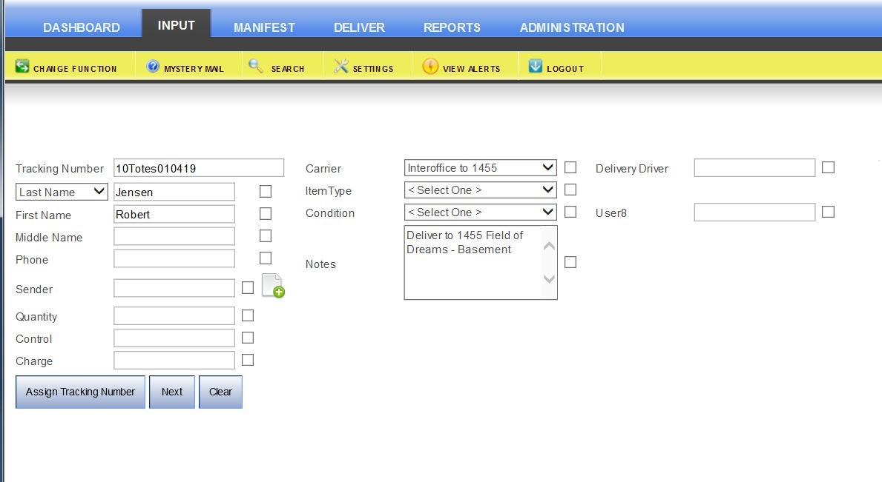
- Check CLIENT HQ Interoffice Transfer Form (Responses) and account for all unprocessed requests.
https://docs.google.com/spreadsheets/d/1Y_qwK7VxGqQMUs4JEcq5bUPsjsLqFMo_O
N0f_em1MYM/edit#gid=1736158042
  - Please check special instructions to make sure that there isn’t something that needs to be picked up prior to the arrival of the interoffice delivery driver.
  - ***Please note*** If there is a large delivery for Sacramento Street that requires more than one trip, immediately send an email to Rodrick Oliver to notify WeWork/Building Property Management of delivery to expedite the delivery upon arrival.
- Interoffice Vehicle dimensions for transport are: 78” x 47” x 45” (6.5’ x 3.92’ x 3.75’.)
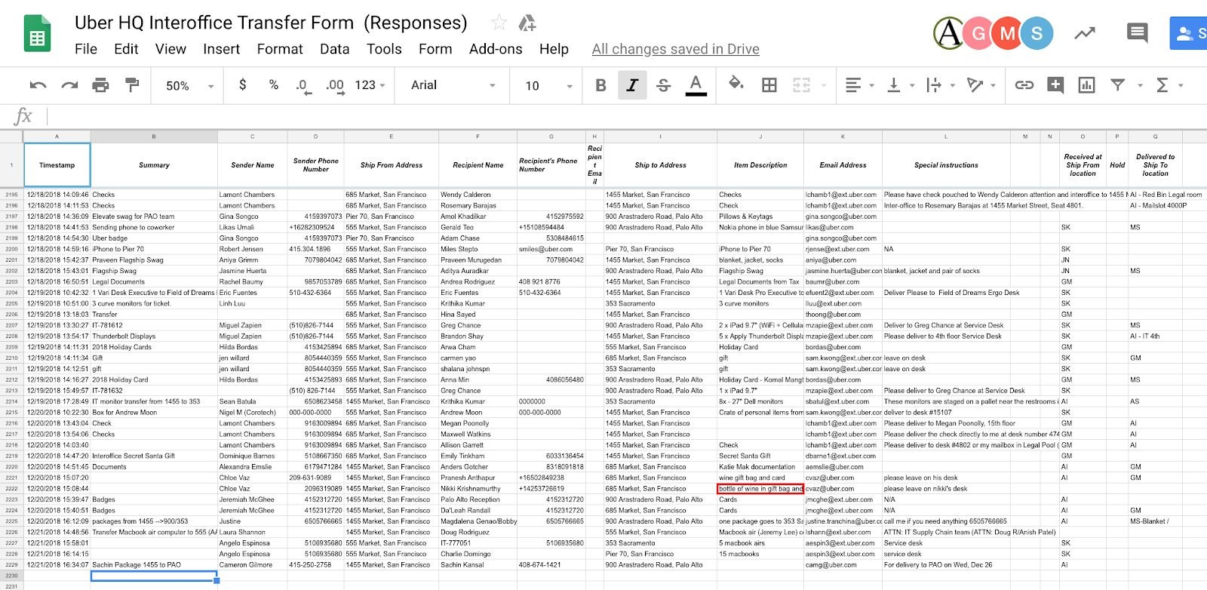
- When gathering mail from the bins for interoffice, make sure that any and all trackable packages/envelopes have a yellow XXX label attached.
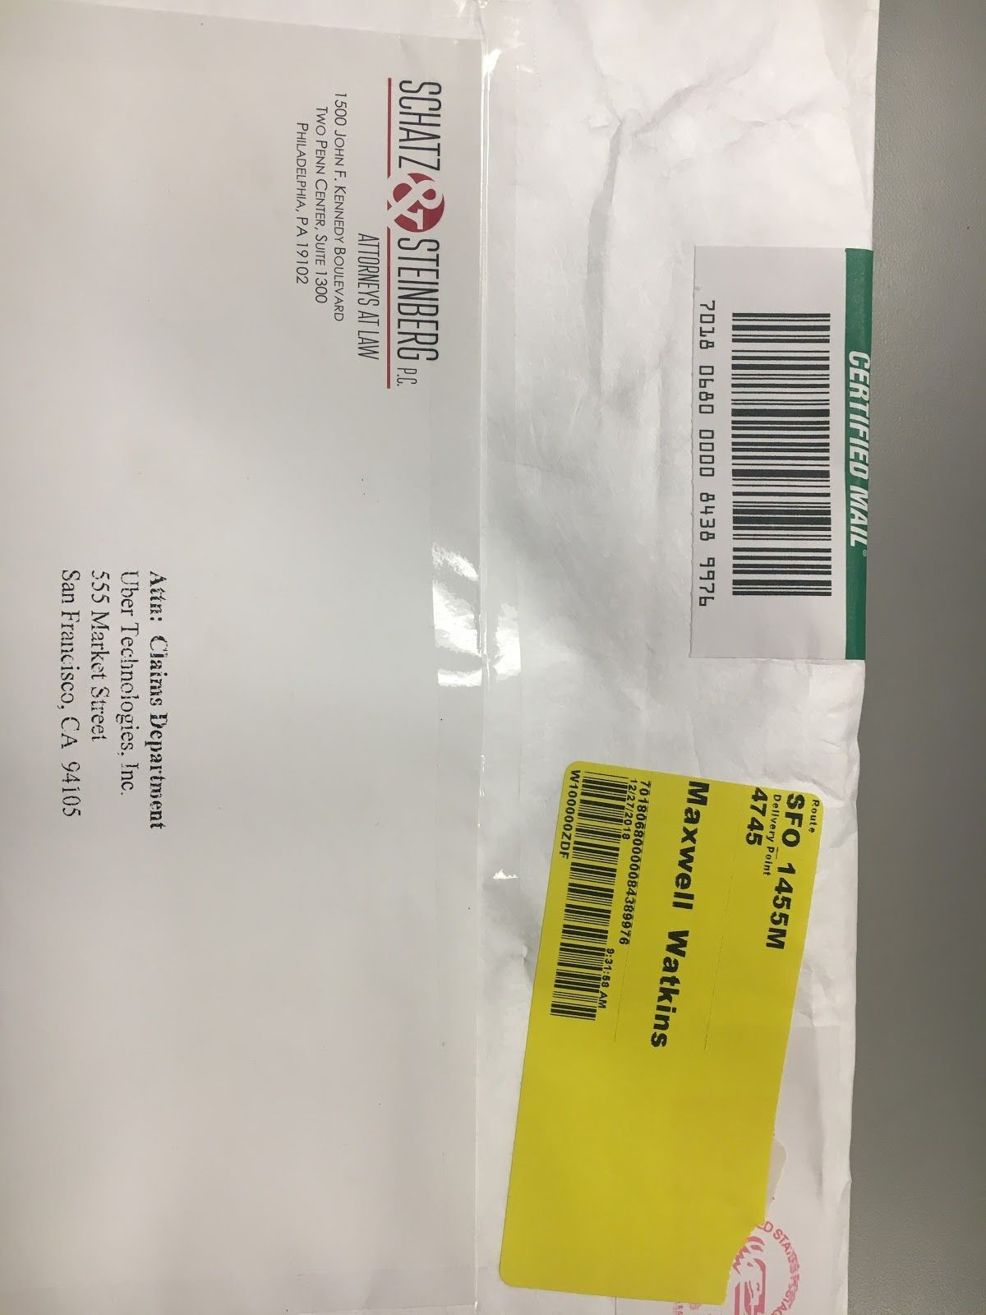
- After creating the Internal Tracking Label, apply the yellow label to the package(s) for Interoffice delivery.
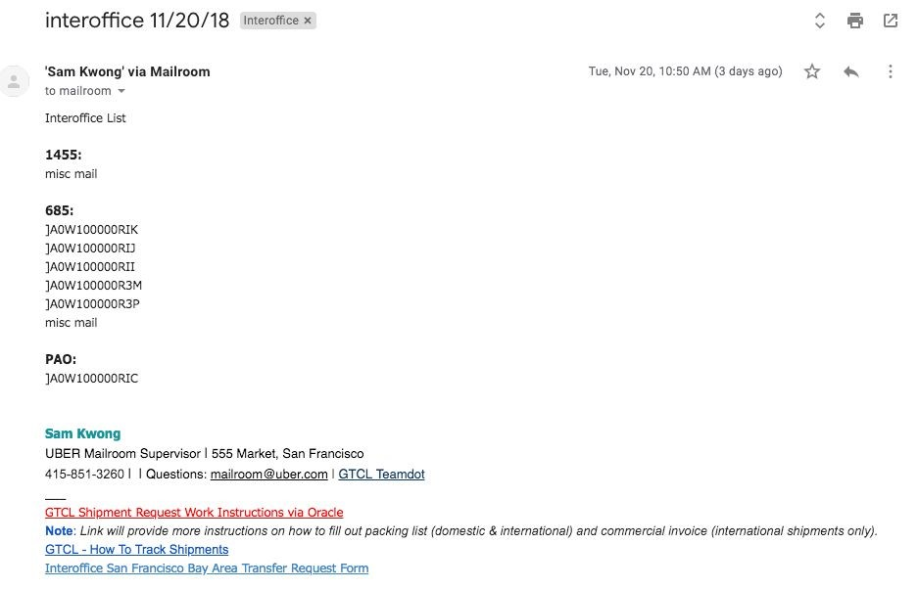
- Upon completion, send an email to mailroom@​ CLIENT.com​ with the following information.
  - Subject Line: Interoffice with Today’s Date.
  - In the body of the email, enter the Receiving Location and all the XXX label IDs below. (See Screenshot.)
  - If there are any unboxed equipment, always include how many blankets are needed for transport. Also, provide a note for special circumstances, such as 5 large monitors need several dollies.
  - If it is for 685, let them know if the delivery requires more than one person and dollies. Manager should be contacted to assist.
  - Once all the necessary information has been provided, send the email out to communicate with the other sites about what to expect upon arrival. Please make sure to include the recipients at the Sacramento Street, Stevenson Streets and Pier 70 in on the emails to make sure that they are communicated to.
- Interoffice Vehicle
  - Inspect vehicle using the Vehicle Safety Checklist using the tablet every morning prior to use. This ​MUST​ be completed before starting the route to be compliant and be done daily before leaving.
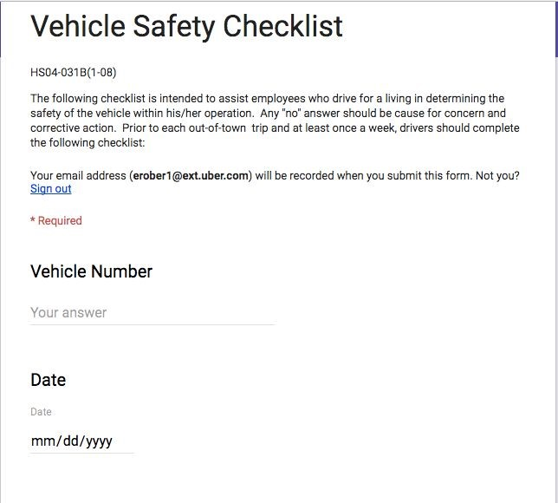
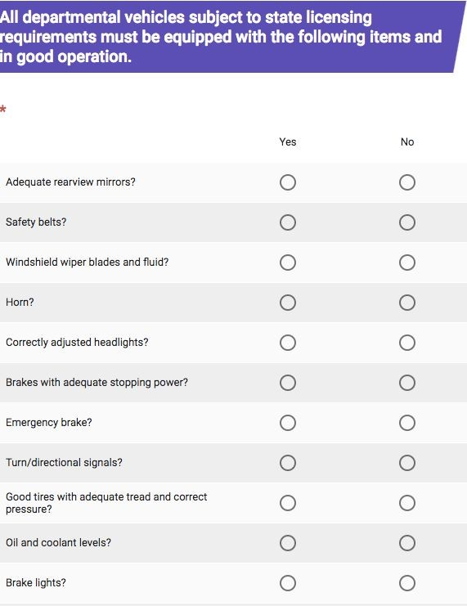
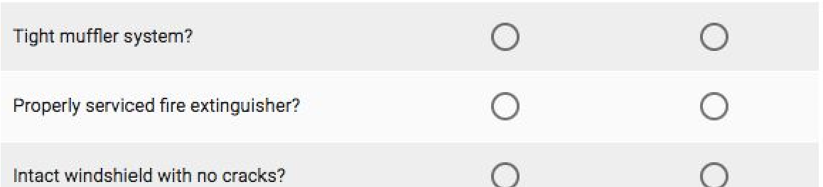
  - If any issues have been identified, contact the supervisor or manager before departure.
  - When loading the vehicle, utilize all safety precautions to secure the load.
- Communication on route.
  - NEVER use phone while driving. Always call the site that you are heading to and let them know that you are leaving a location before starting the vehicle. This will give them time to prepare their Interoffice shipments and reduce the wait time upon your arrival.
  - When driving always be aware of your surroundings. Always take extra care during hazardous conditions such as pedestrians, rain and traffic congestion. Utilize your horns and and hazard lights when backing up while checking your mirrors. These are to be used to let people and other drivers know that you are there. Always obey all traffic laws.
  - When you arrive at the location, call the site again to let them know that you have arrived. (If you are unable to get a hold of anyone at the site, ALWAYS contact HQ so that they can contact the receiving site for you.)
  - Once they have come to meet you, deliver the packages that you have for that site and retrieve the packages that they have for you along with a manifest to account for the packages you are receiving.
  - Upon completing the transaction and prior to starting the vehicle, contact your next destination and let them know that you are about to leave for their site.
  - If you are unable to contact any site for any reason, ALWAYS contact HQ so that they can contact them on your behalf.
  - If someone is trying to get a hold of you, NEVER answer your phone while driving. Pull over as soon as it is safe and possible, then call them back in case of an emergency or change of plans.
  - When delivering to Sacramento Street, see Sacramento Street Specific Instructions. Section 18.5.
- Sites receiving packages from interoffice delivery.
  - Make sure that all packages that are being received from the interoffice delivery containing a trackable label also has a yellow XXX label. Notify management immediately and apply a yellow XXX label for accurate delivery.
  - After receiving interoffice packages/mail, make sure to update the CLIENT HQ Interoffice Transfer Form to sign off on the receipt and for special instructions for delivery.
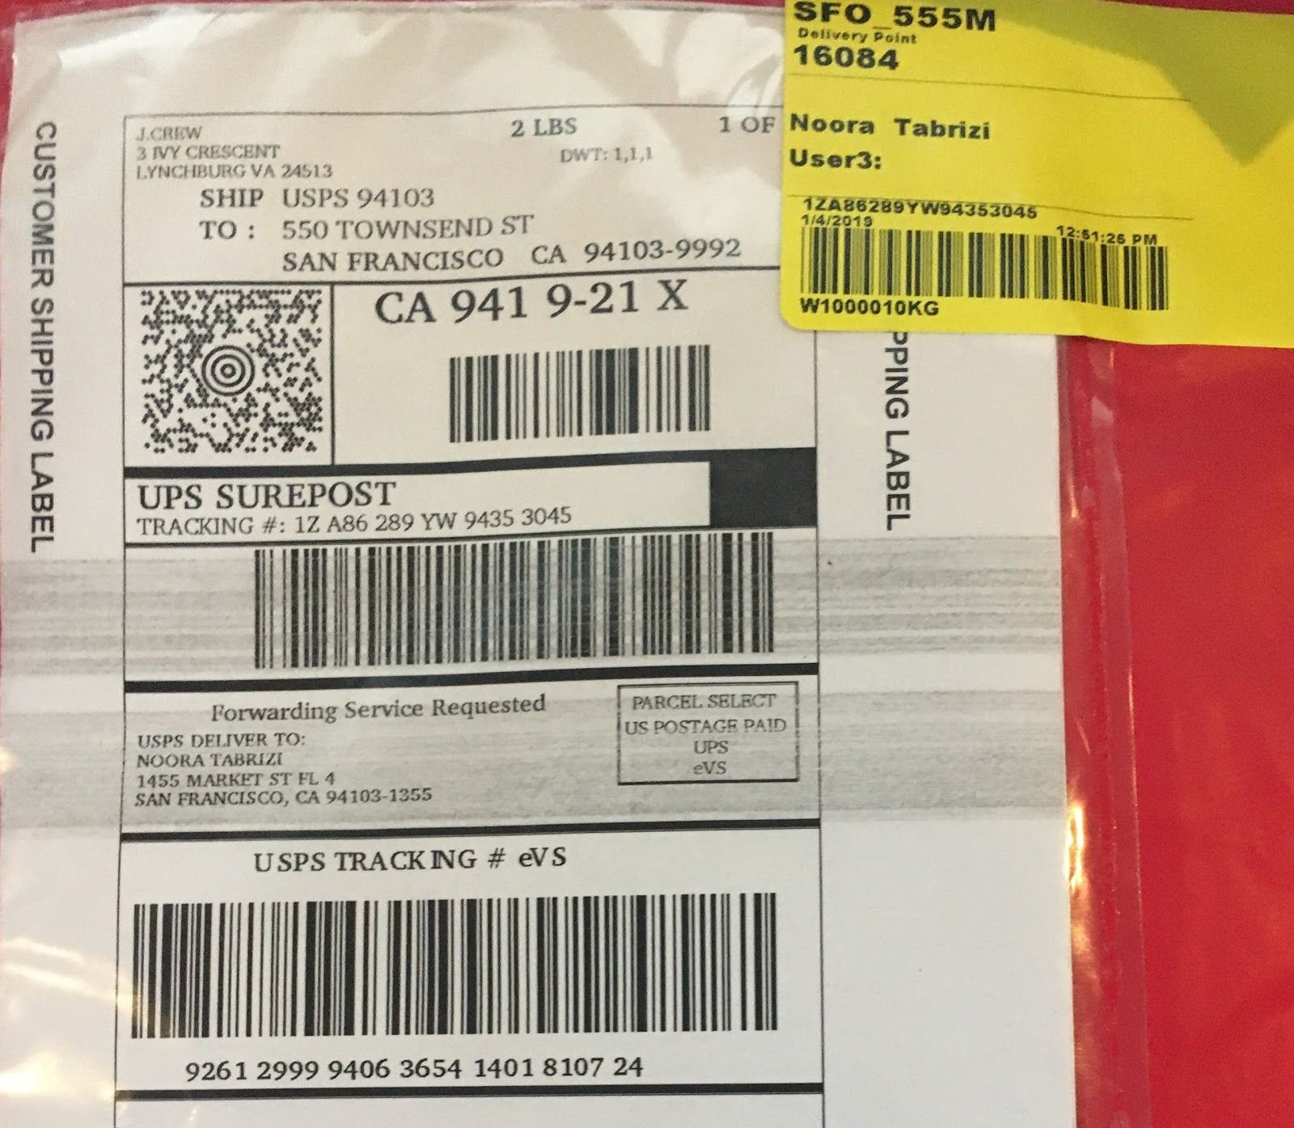
  - Inbound all packages with the yellow XXX label to notify customer that the package has arrived at the correct destination.
9.3.1. ***Important*** Make sure to scan the yellow XXX label not the original tracking label to inbound scan into XXX. This will enable you to input the correct consignee information for delivery.
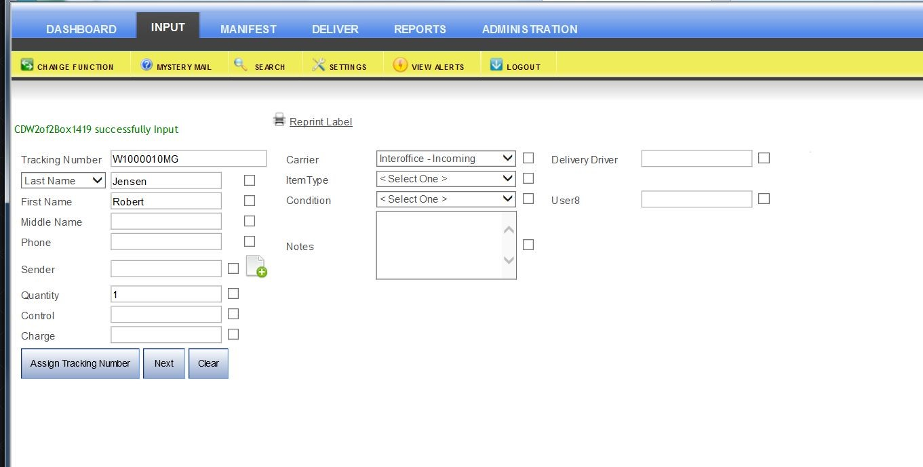
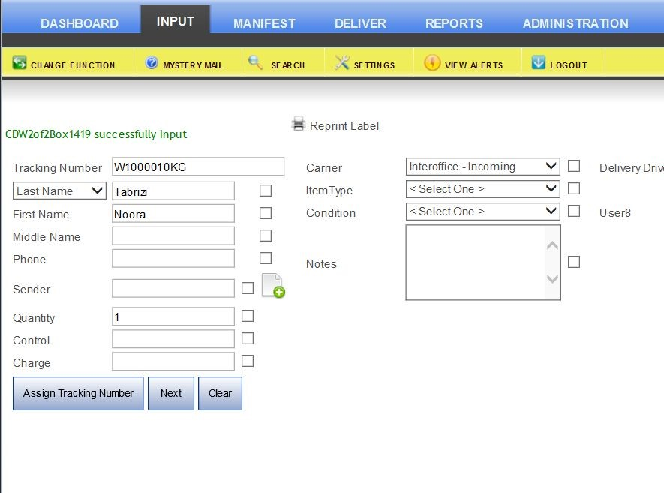
  - A new label will be created after clicking the next button.
  - Place the new label over the old yellow XXX label.
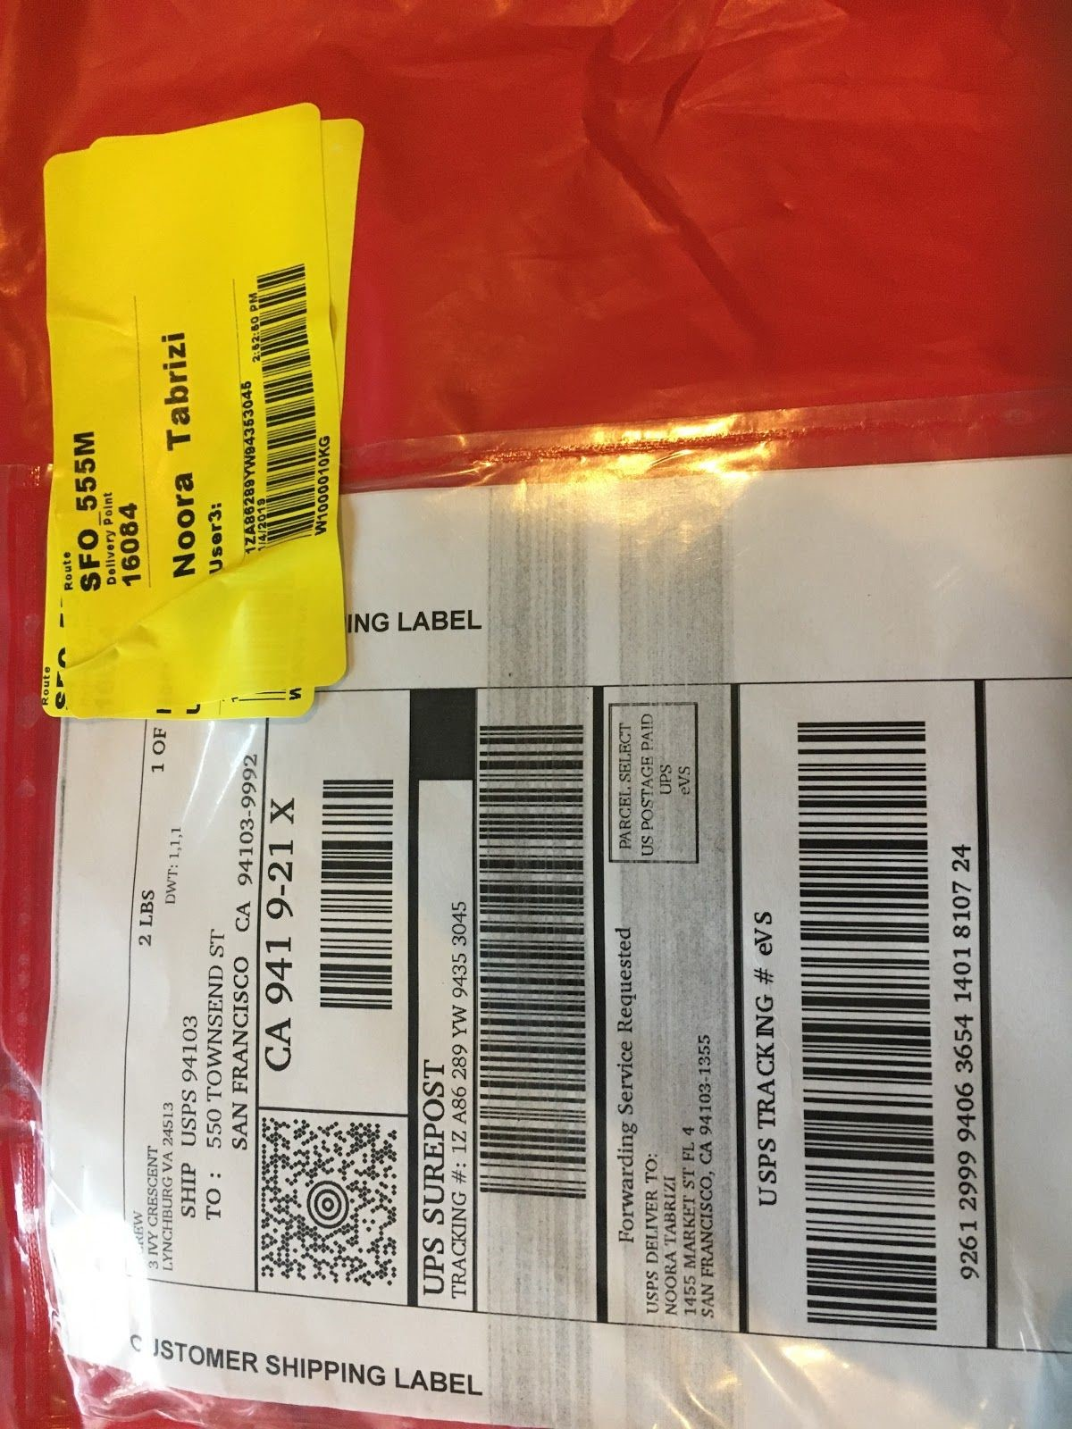
  - After inbound scan is complete, delivery package as usual.

12. Hold at Location
Purpose:
To ensure packages are held and marked per the request of the recipient while holding them accountable in picking up the package within 30 days.
Procedure:
- When a customer requests for a package to be held at location, make sure to get a date of when exactly they will be coming to pick up the package and inform them that the package will be returned in 30 days if they do not pick it up. Once you have confirmed the date, print out the email, attach it to the package and place on the holding shelf.
- If the customer has not picked up the package by the date that they provided, send them a follow up email informing them that if they do not pick up the package within 30 days of the receipt of the package, that it will be returned back to the sender.
  - Use the 2nd, 3rd and final notice templates if necessary.
  - Please update the 1455 Not in System Log for every time an email is sent out.
- After sending the final notice, immediately inform supervisor or manager for further instructions before returning to sender.
- Please make sure to sign out from the 1455 Not in System Log before returning to Sender.

13. Hold at Location - EVENTS
Purpose:
To ensure​ all packages are received and held at specified location for events.​
Procedure:
- If a customer reaches out to have packages held for an event, ALWAYS ask for the following information:
  - Tracking information.
  - How many packages are to be expected?
  - Where will they be delivering the packages?
  - When and where is the event taking place?
  - When and where they would like to have the items delivered the day of the event?
- Once you receive the information, print out the email with all the information and communicate it to the inbounding mailroom team.
  - ALWAYS follow up with your team.
  - If you are communicating with the customer, it is your responsibility to follow up with the mailroom team.

14. Not in System
Purpose:
To ensure proper handling of packages for recipients who are not in the XXX system and show the package has been received in the mailroom.
Procedure:
- If the name on the package does not appear in the system, use Unknown (mailroom) in the following screen and make sure to put in notes who shipped the package along with their address. Include the person’s name if there is one in the field marked NIS (Not in System).
- Once the label is printed, apply to package and make sure to print the date on the package to track how long it has been sitting on the shelf.
- If the recipient is on HR TECH, contact them via email using the “In HR TECH, Not in System” template to contact them.
- If they want to have the package held at location, follow the Hold at Location procedures.
- If there is no recipient, but says CLIENT. Reach out to the sender. 5.1. If a phone number is listed on the Ship From Address, contact the number and ask the sender if the person is an CLIENT employee or if it was meant to be sent to the address where it was received, ie. 1455, 685, 555 or Palo Alto address.
5.1.1. Shipper may be able to provide you more information for delivery of package or request to have it sent back them.
5.1.2. There is also a possibility of having the shipment discarded if perishable.
5.1.2.1. If this is the case, still scan package into XXX as unknown.
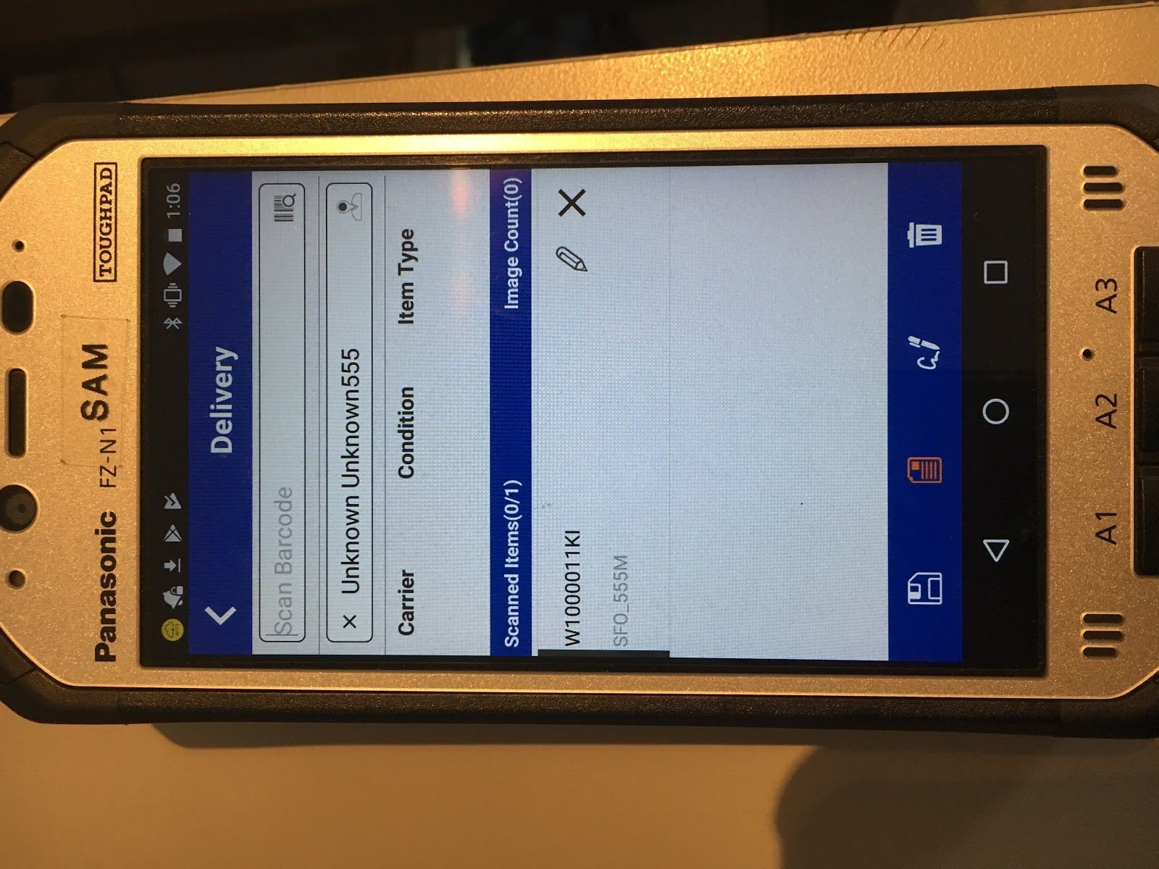
5.1.2.2. Under notes, write shipper instructions, save and discard.
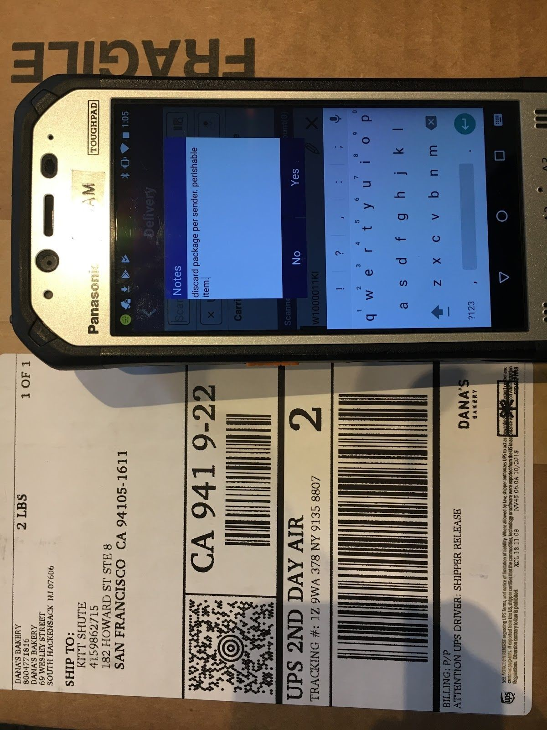
  - If a phone number is not listed, but a company name is listed; contact the company customer service by doing a Google search for the company’s customer service telephone number.
  - If there is a reference number, purchase order number or order number; take note of it and provide the customer service representative with that information. It should minimize the amount of time spent with them on the phone and be able to retrieve some sort of pertinent recipient information.
  - If they are unable to provide you with any useful information, hold package for 30 days before sending back. Chances are, someone will come by to pick it up or it belongs to one of the other tenants in the building.
  - Please make sure to sign out the package from the 1455 Not in System Log before returning back to shipper or if Square or any other company comes to retrieve packages. Please use the clipboard to put the name of the person on the package being returned along with the date removed.

15. Return to Sender
Purpose:
To ensure that all possible forms of contact has been exhausted and the opportunity for the recipient to retrieve there package before the 30 days while preventing having too many packages in the mailroom. To hold customer accountability by providing follow up emails before sending back to the shipper
Procedure:
- When a package is scanned via the xxx system an email is sent to the customer notifying them that a package has arrived in the mailroom.
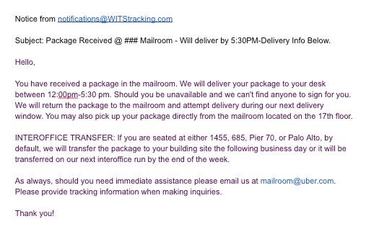
- If the package has arrived and the customer has not been available, a follow-up email must be sent 14 days after the initial email with a second notice (use CP Follow-Up Form-2nd Notice template.) Mark box with a check mark to signify that the second notice has been sent and notate it in the 1455 Not in System Log.
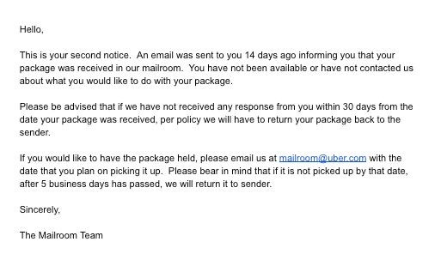
- If the customer still has not responded after 21 days, send a 3rd notice (use CP Follow-up Form-3rd Notice template.) Mark the box with another check mark to signify that the third notice has been sent. Make sure to always fill out the 1455 Not In System Log every time an email is sent.
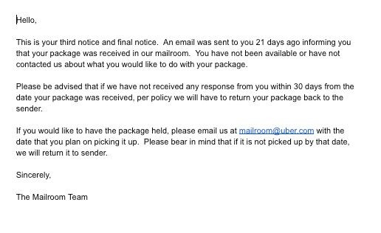
- If after 30 days, the customer has responded, send the final notice (use CP
Follow Up Form-Final template) to let the customer know that due to their
lack of response, per policy we will be sending package back to the shipper. Always make sure that the
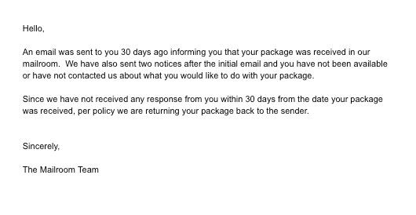
- Document the name (if applicable), tracking number, carrier and date of RTS. Before sending back to the shipper, check with supervisor or manager to inform them that a package is being sent back to make sure procedure has been followed.
- With supervisor or manager approval, write “Return to Sender” on the package with the arrow pointing back to the shipper. ALWAYS make sure that the courier/driver that you are handing it to either scans the package as received or signs a manifest of the list of packages that the driver will be retrieving so that we have confirmation of receipt.
- If courier/driver does not scan packages or will not sign off on the manifest, retrieve packages and await further instructions from supervisor or manager.

16. Outbound (Oracle)
Purpose:
To be in compliance for shipping CLIENT Business related shipments. Procedure:
- Shipment requests will be sent via Oracle. See the 110 page GTCL Work Instruction via Google Docs at https://docs.google.com/document/d/10QEKbI3mmCw_VnPvrR3wrhiQ3Zz kh05yGras17nuEXE/edit?ts=5c1794c3​.
- There will be two types of shipments:
  - Documents of no value.
  - Contents.
    - Items containing Lithium Ion batteries such as notebooks, tablets, phones, etc. must be approved by Logistics.
    - Quantity of devices per box:
      - 15 phones.
      - 10 tablets.
      - 5 laptops.
    - For 2 or more devices, take a photo of the package unsealed and send to the Logistics team for approval.
    - Utilize the UN-3481 Label in color and place on package.
- Shipments will either be sent Domestic or International.
  - Domestic shipments.
    - Mailroom is authorized to ship both contents and documents of no value.
  - International shipments.
    - Mailroom is only authorized to ship documents of no value internationally.
    - Contents going Internationally can only be processed by the Logistics team.
      - A Logistics team member will forward the email with a label from the 3rd party courier, to print out and place on the package going out for delivery. Make sure to place the label inside a packing sleeve to protect from weather damage.
      - The 3rd party vendor will contact mailroom upon arrival and retrieve package for pickup and delivery.
- Oracle request timeline:
  - Requests in Orders - To Be Planned must be moved to next stage (Shipments - To Be Tendered) within 30 minutes to an hour.
  - Check “Orders - To Be Submitted” on a daily basis to make sure that there is anything that should have been sent to Orders - To Be Planned. Chances are, the Requestor failed to submit it the second time.
  - Add Tracking Events for “Estimated Delivery” and “Picked Up,” must be done after completing the oracle process.
  - Status of shipments that have been sent out must be tracked daily to ensure delivery or if any delivery exceptions has occurred. They must be added to Tracking Events. “Delivered,” status must be completed when the package has been delivered. “Delivery Exceptions,” must be added to tracking events with explanation.
- Process shipments using FedEx.com.
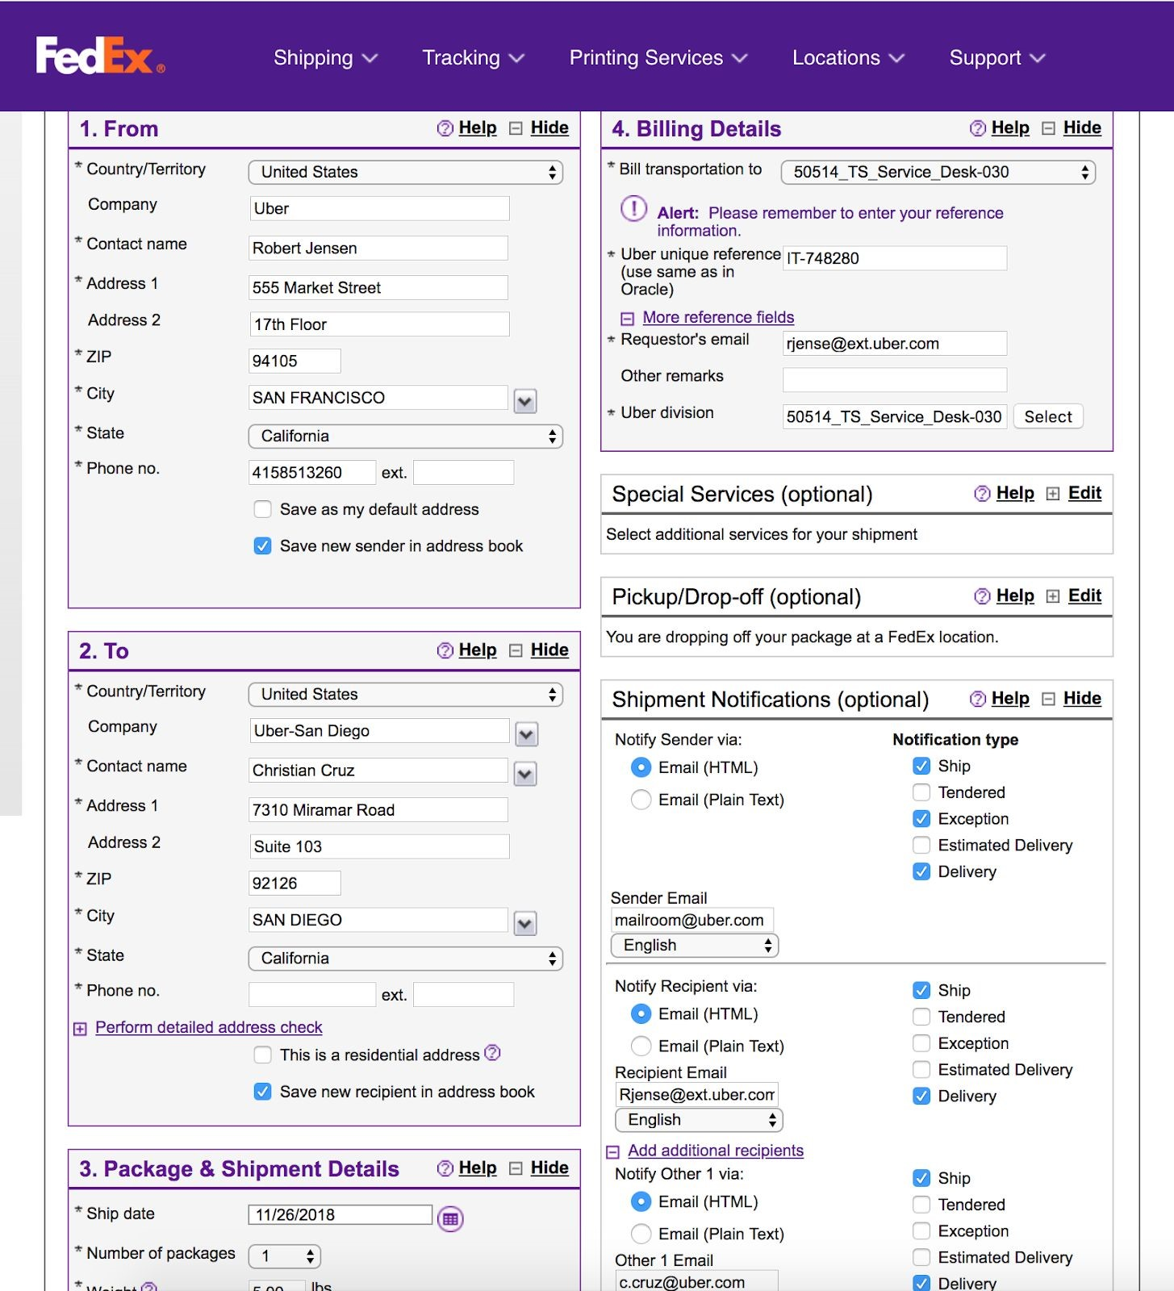
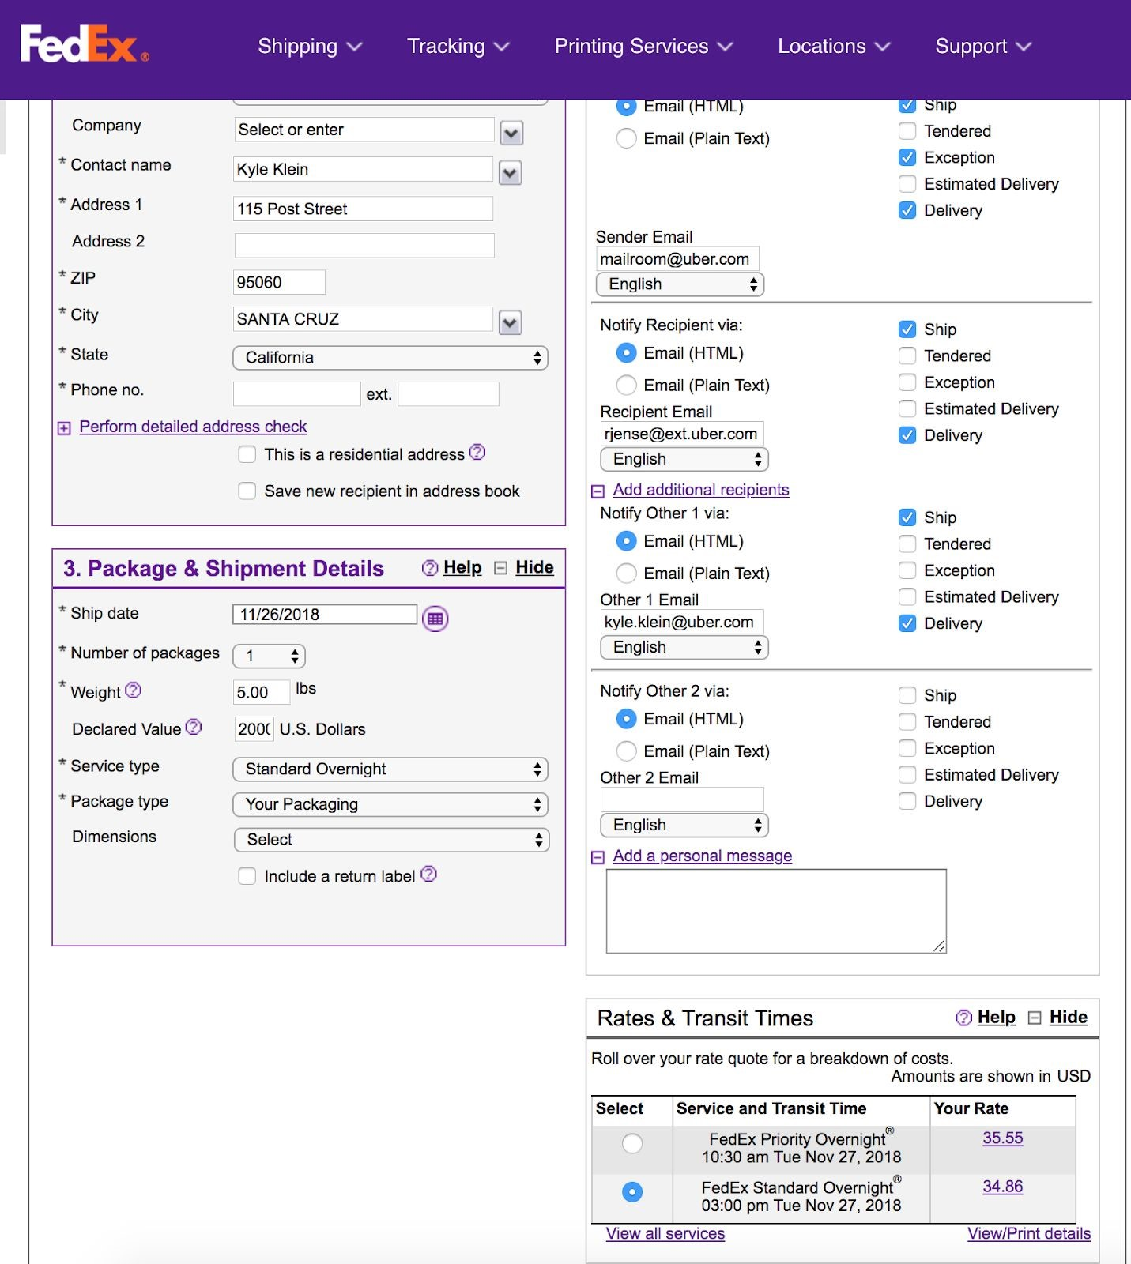
- Save a copy of the FedEx Label to your computer using the tracking#_Reference# as the filename.
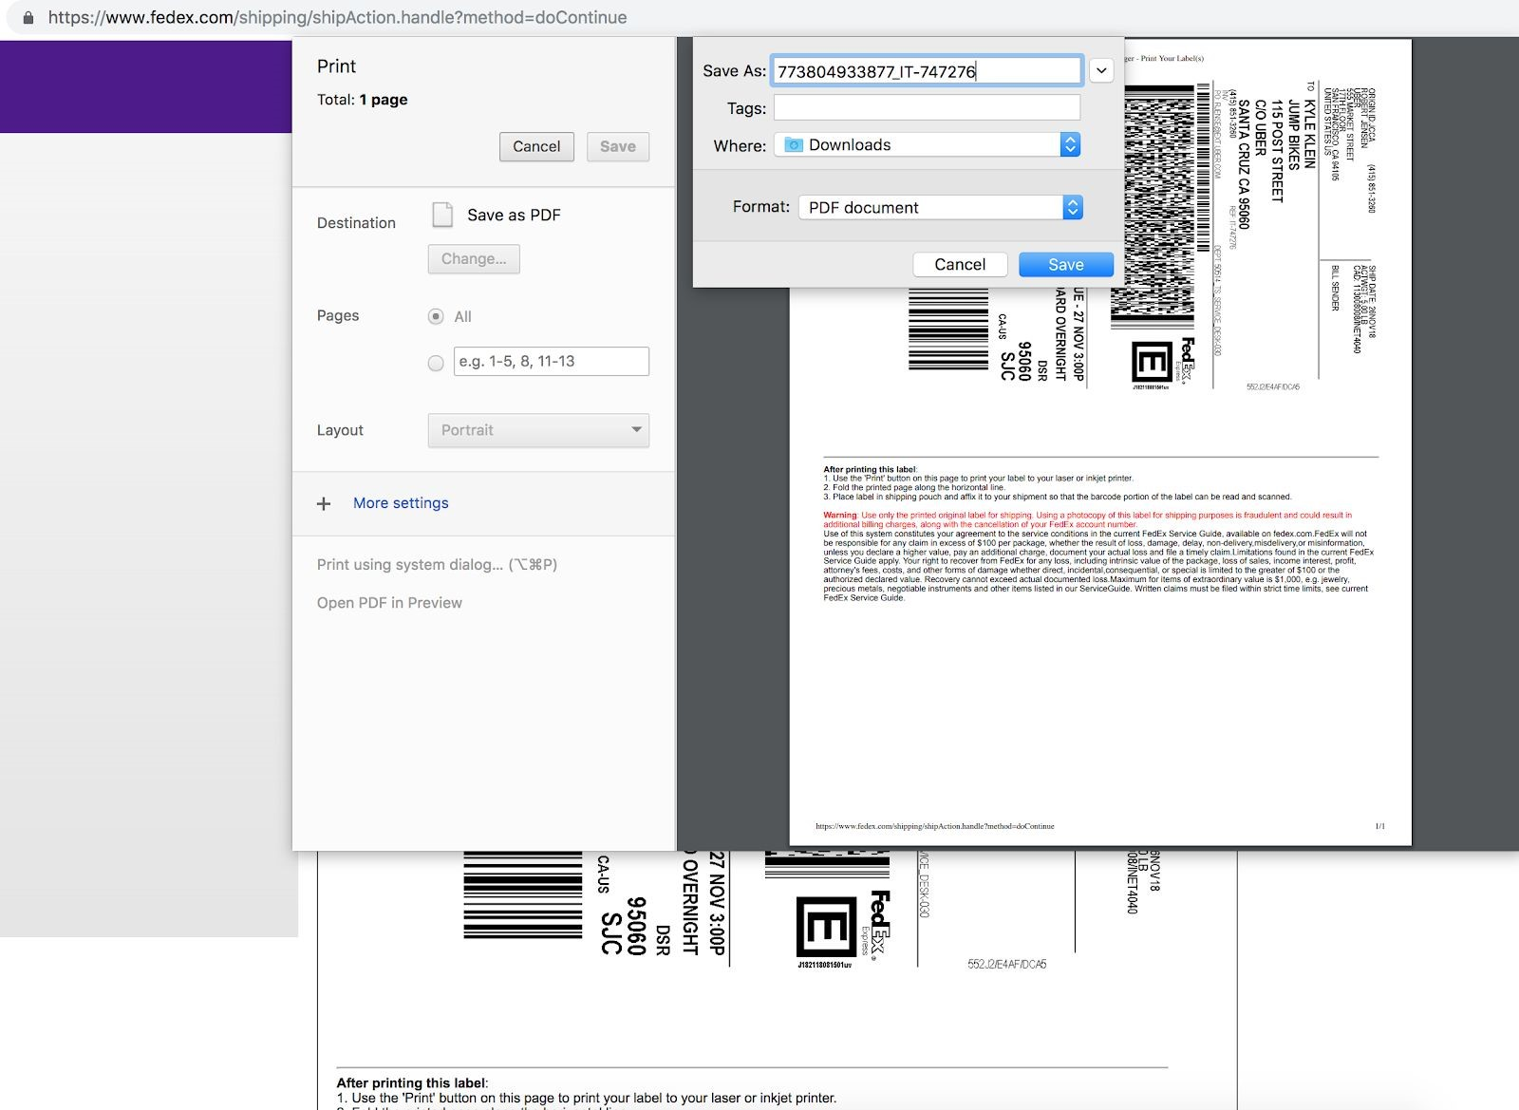
- Upload the .PDF file of the FedEx Label to both Oracle and Box when first processing shipment.
- To upload to Oracle, check the box next to the Oracle ID# that you are working on. Click actions above and select upload document.
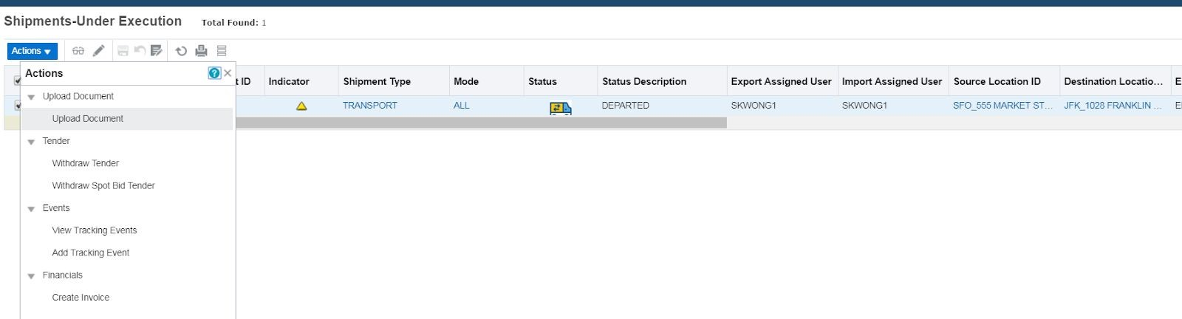
  - A new window will pop up. Click “choose file” to select the file that you created in step 4. Select the file and click “open.”
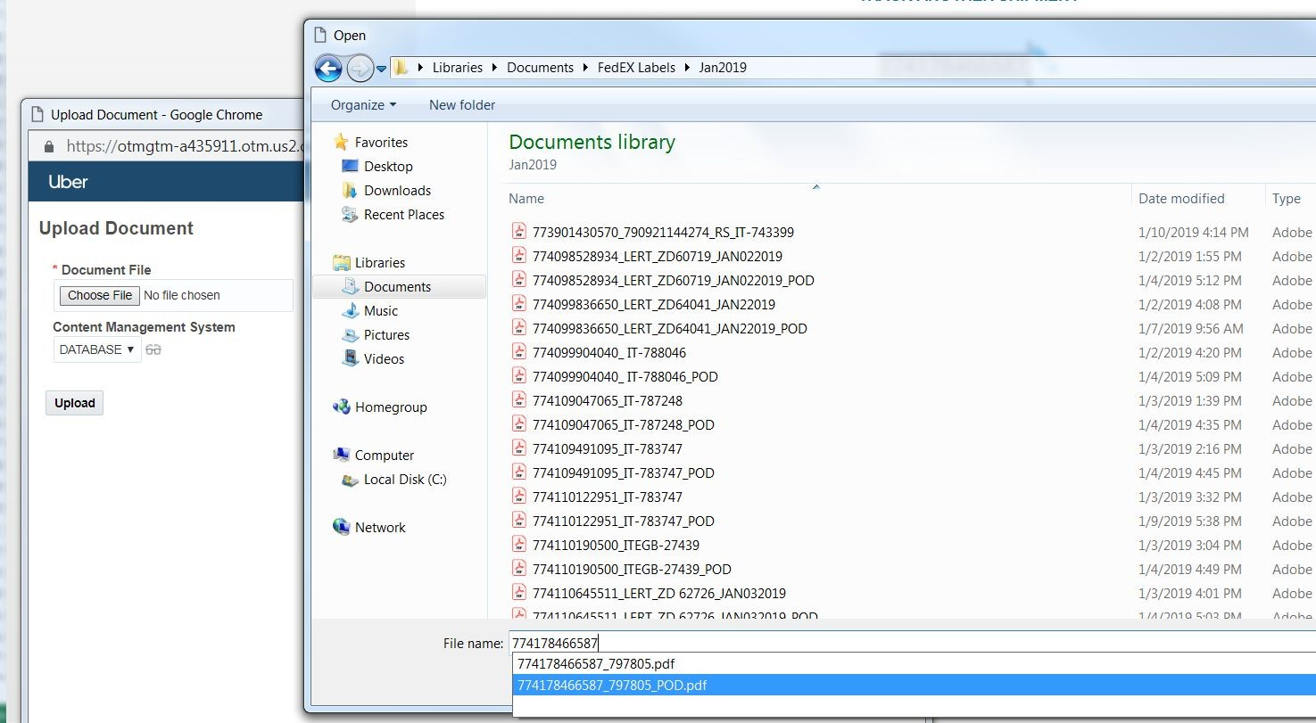
  - Once file has been selected, click “upload.”
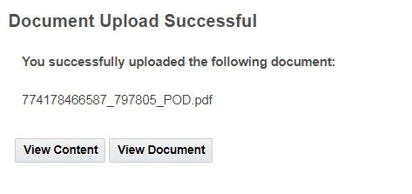
  - After the uploading document, a window will appear informing you that the document has uploaded successfully.
- To upload to Box. Go to OneLogin and type in Box in the search bar.
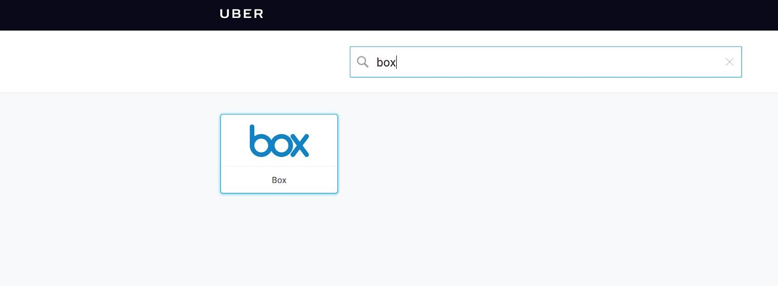
  - Click on Box and it will take you to a different screen. Select Shipment Records.
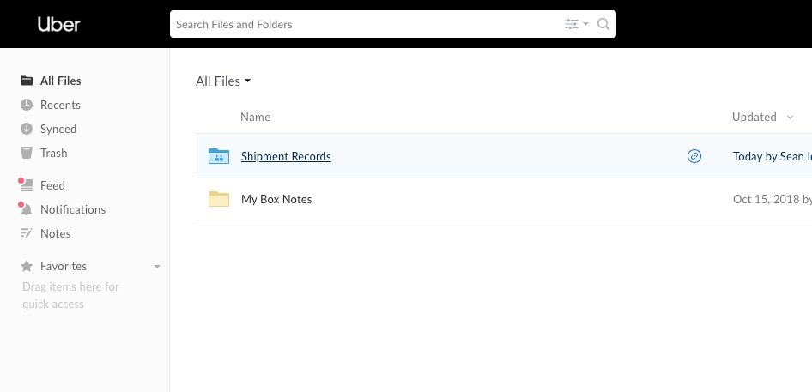
  - It will take you to another screen, select Shipment records again.
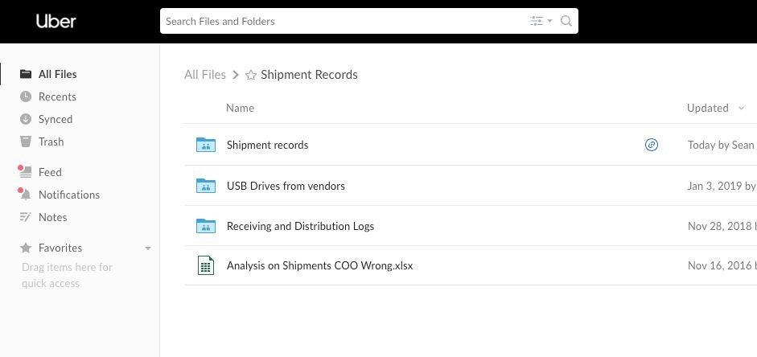
  - Select the folder for the current year.
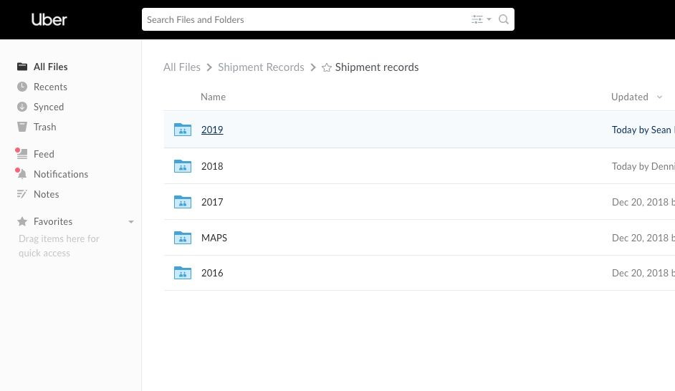
  - Select the folder of the call center for which you are processing. (This can be located by searching the requester’s name in HR TECH and finding their call center on their profile.
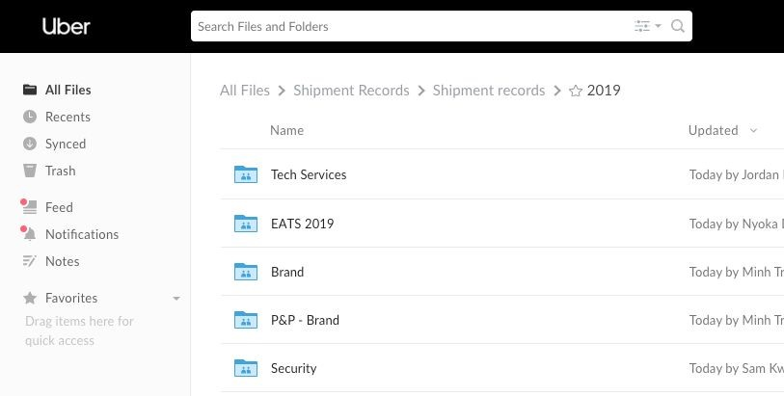
  - Select the Americas folder.
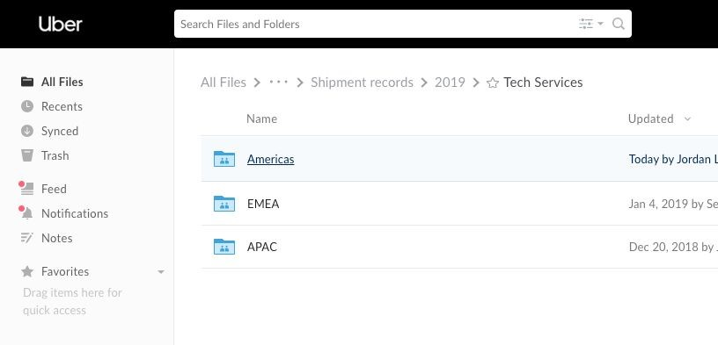
  - Select the US Domestic folder.
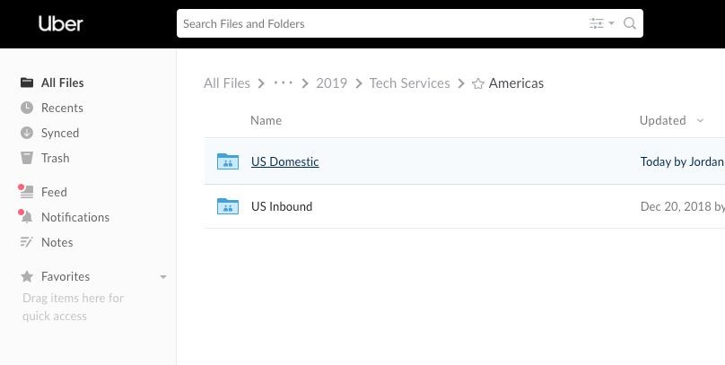
  - After selecting US Domestic, create a new folder by click the New button which will generate a drop down menu. From the drop down menu, select Folder.
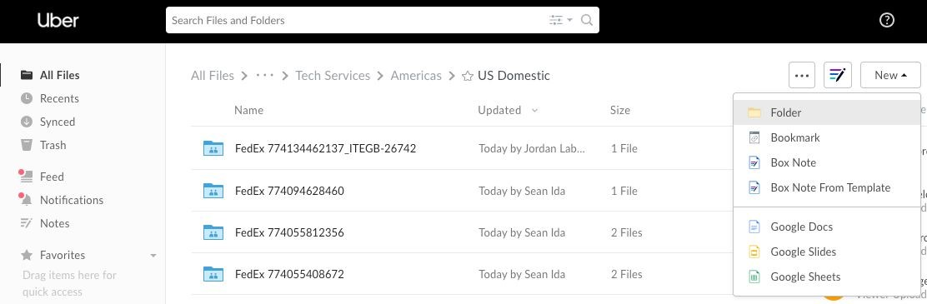
  - A new window will appear, name the folder using the courier service (in this case, FedEx) a space, the FedEx Tracking number, underscore, the Reference #.
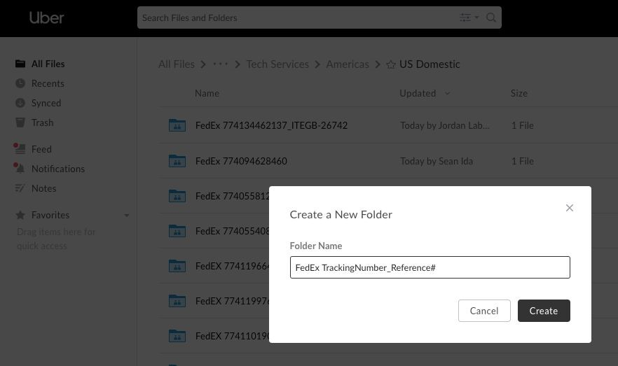
  - The folder will be created in which you will be able to upload the .PDF file of the FedEx Shipping label.
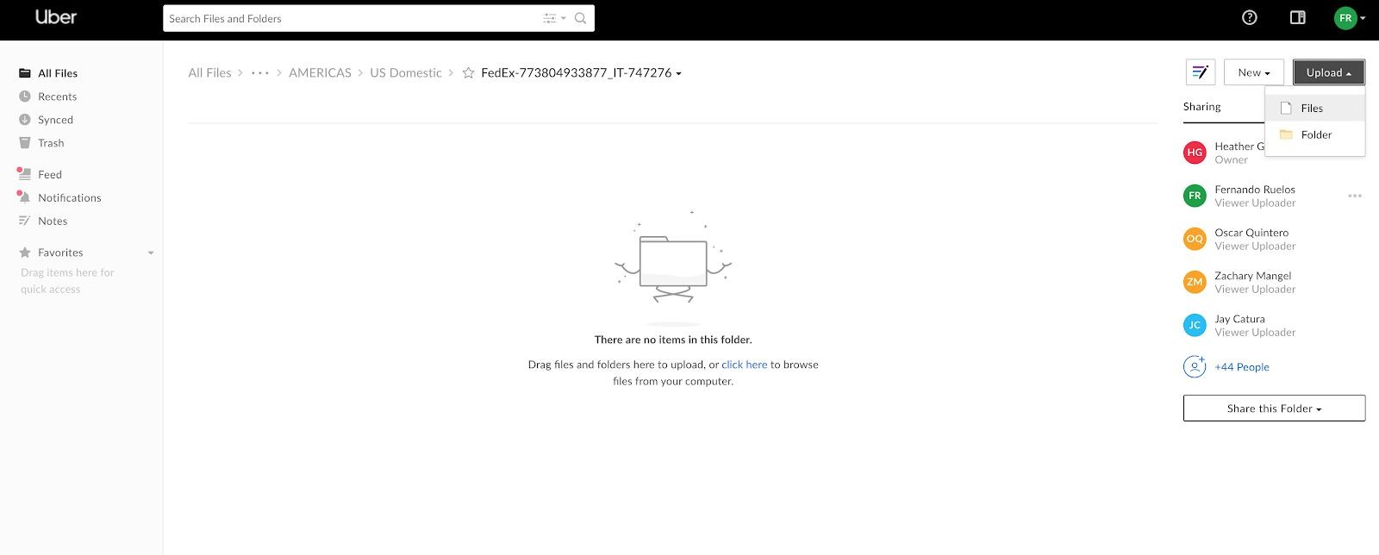
  - Click on the folder and choose the Upload button and select file.
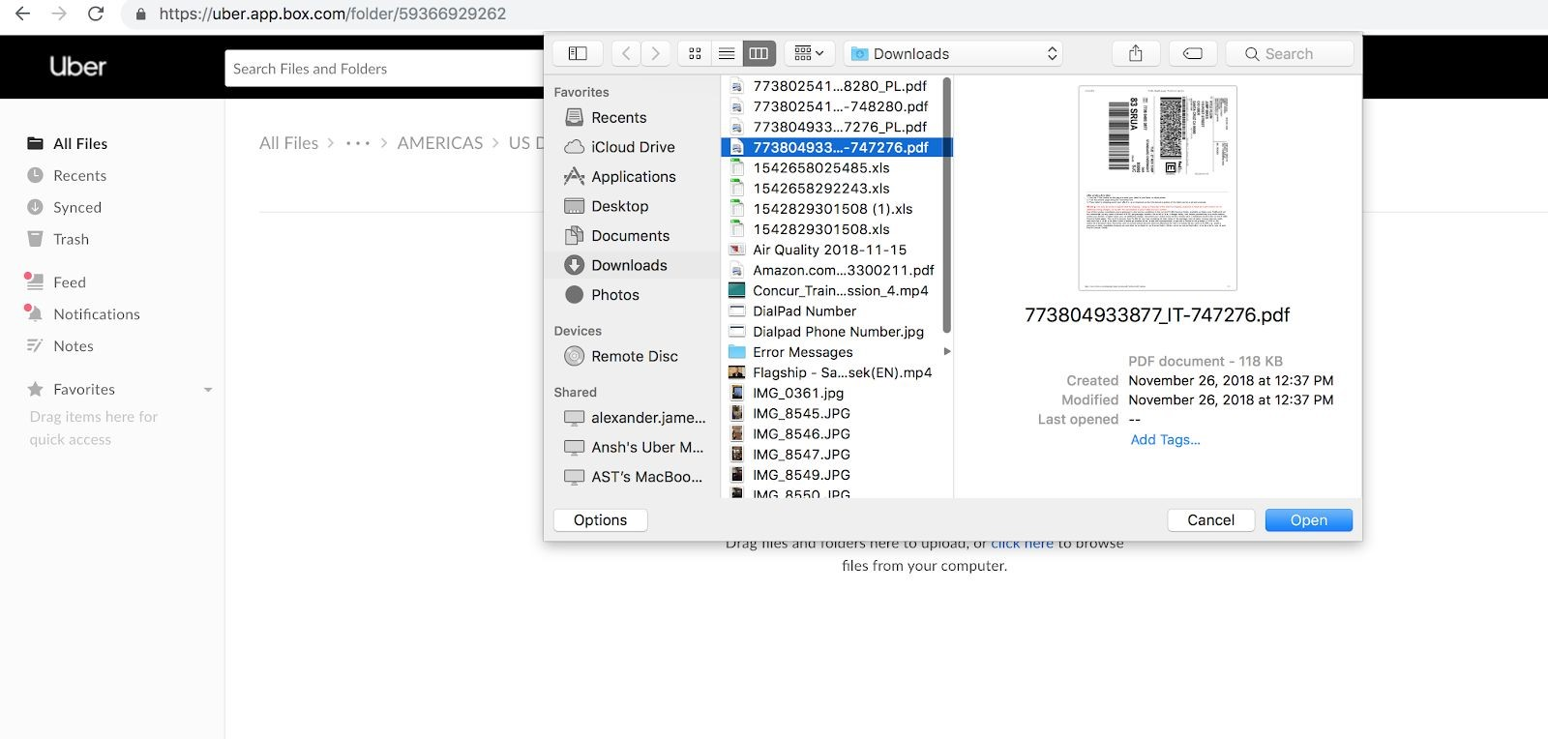
  - A window will appear for you to choose the file you would like to upload. Select the file and click on the Open button.
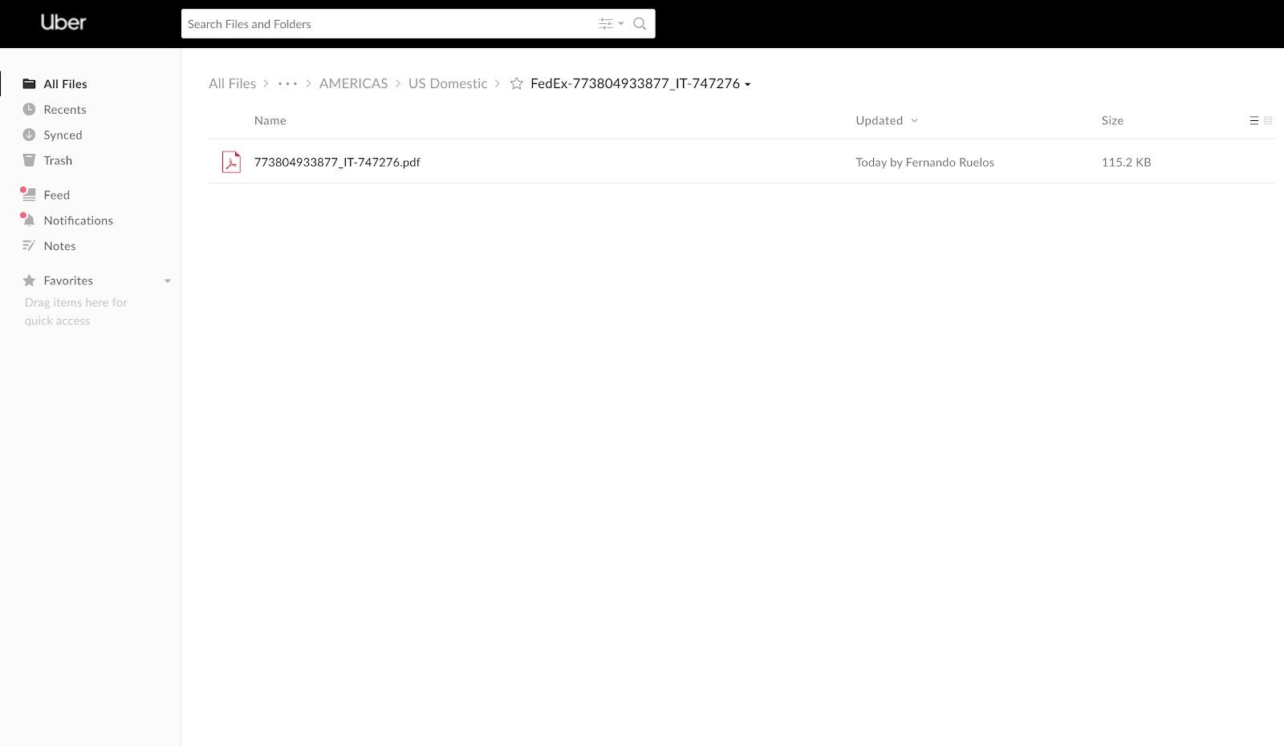
  - This will upload the file into the folder.
- After package has been delivered and added as a tracking event in Oracle, obtain the Proof of Delivery from either the FedEx email notifications or tracking it on the FedEx website.
  - Go to the FedEx.com website, access the tracking function, enter the tracking number and click on Track.
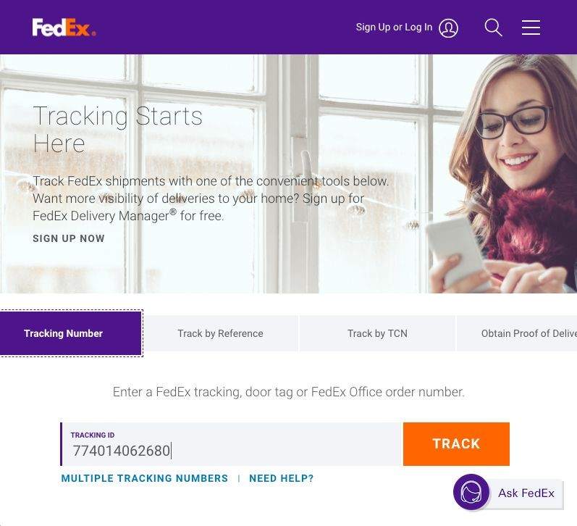
  - Another screen will appear with package delivery information of date, time, who signed for it, etc.
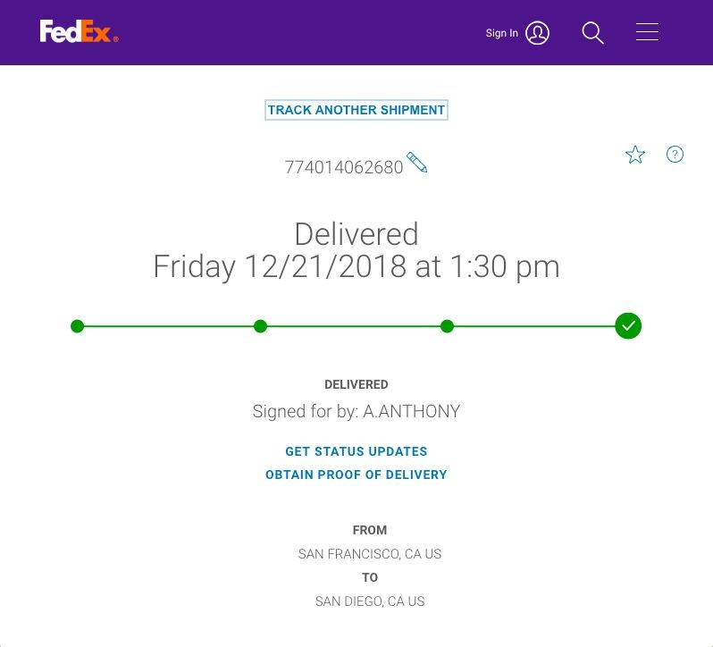
  - Click on “OBTAIN PROOF OF DELIVERY” and it will bring you to the bottom of the screen where you can submit a request for proof of delivery.
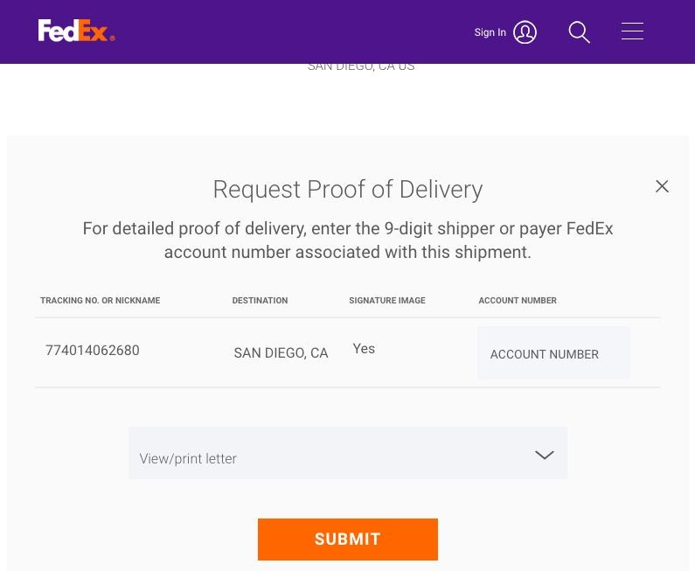
  - Click the submit button and it will open another screen will detailed delivery information and proof of delivery.
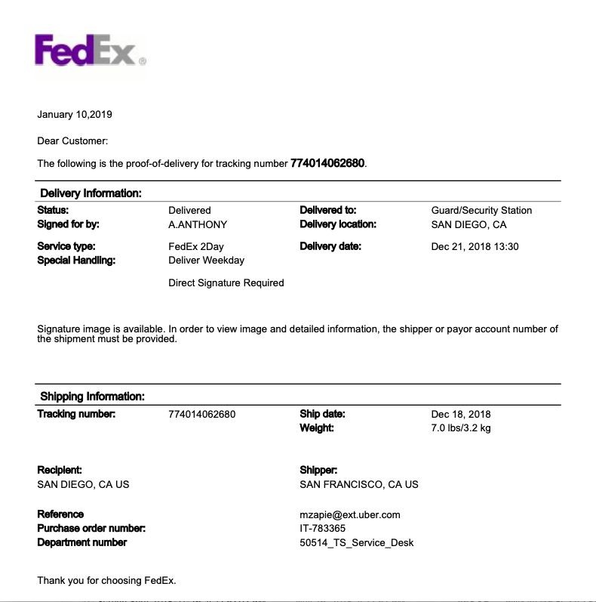
  - Click on the download icon to save the document as a .PDF.
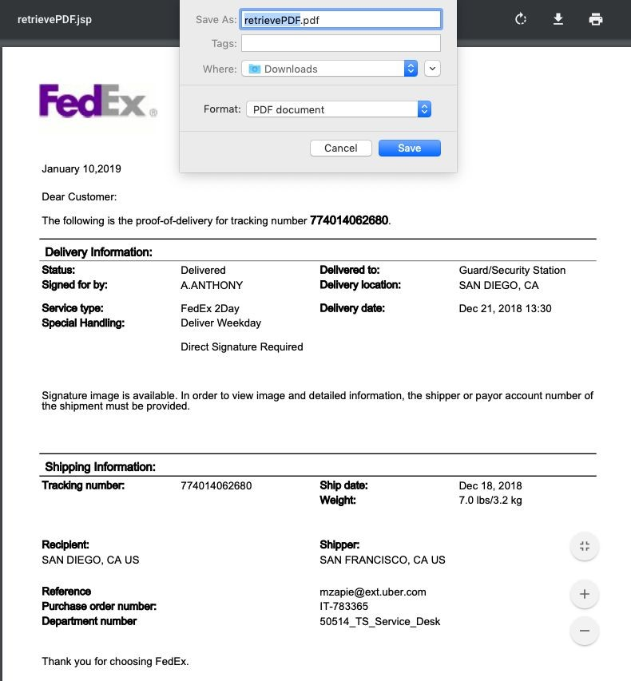
  - Use the tracking number_reference#_POD as the file name.
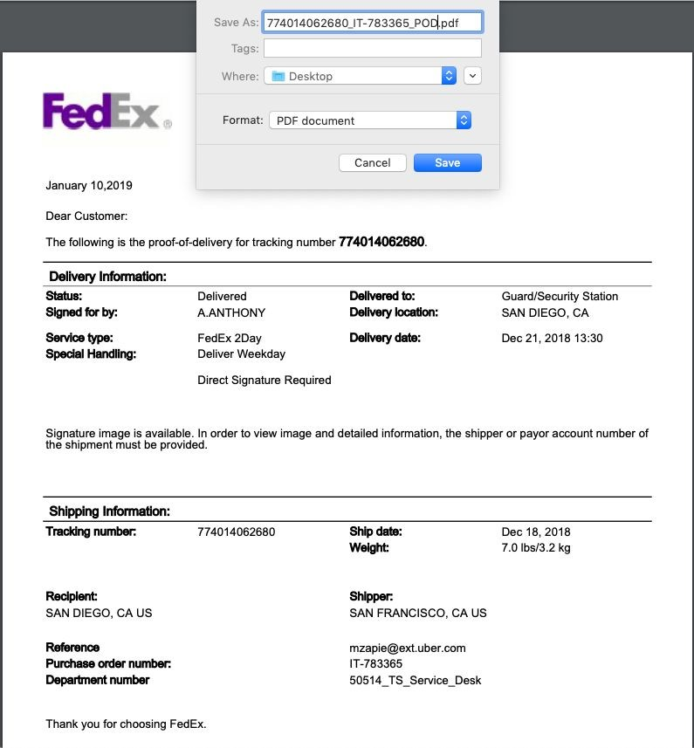
  - Save file and follow steps 5 through 7.6. A folder should have already been created for which the tracking label was placed. Use the search option to locate the folder by typing in the tracking number in the field.
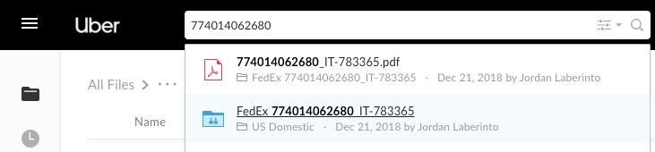
  - Select the folder.
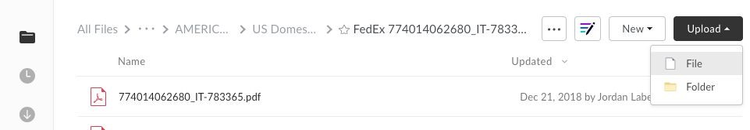
  - Click Upload and select the POD file
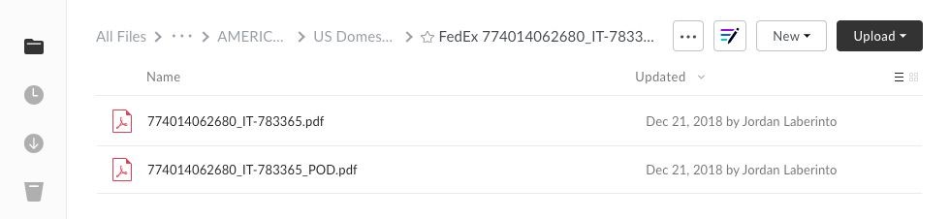
- For issues regarding Oracle, reach out to the logistics team through the SFO Mailrooms uChat for questions.

17. Reports
Purpose:
To ensure that reports are completed on a daily basis and submitted to manager.
Procedure:
- Monthly Metrics.
  - The monthly metrics should be done on a daily basis.
  - The numbers for the previous month should be completed and provided to the site facility manager on the first day of the month.
- Undelivered Reports.
  - Please pull the undelivered Reports on XXX daily to make sure packages that have been delivered are not on this report.

18. Site Specific Miscellaneous
Purpose:
Information regarding site specific procedures and miscellaneous information.
Procedure:
- 555 Market Street​.
  - No loading dock available.
  - Shipments received behind building on Stevenson Street at the garage level.
  - Mailroom located on the 17th Floor.
  - Floors Serviced - 2nd, 4th-17th, 19th - 21st
  - Pick up and delivery.
    - When using hand carts, dollies, etc. freight elevator must ALWAYS be used.
  - CLIENT receptionist is located on the 1st Floor in the lobby.
  - If there are more than 2 pallets being delivered, it must be delivered before 7AM or after 6PM. Which will be arranged with the facilities team. Otherwise if delivered between 7AM and 5PM, mailroom team will receive and breakdown pallets on the street level.
  - For safety reasons; no pallets, pallet jacks, dollies, or anything on wheels should be out on the floor. Pallets should be broken down and stored appropriately.
- STREET-NAME.
  - No loading dock available.
  - Shipments received behind building on Stevenson Street using freight elevator from the basement floor.
  - Mailroom located on the 10th Floor.
  - Floors Serviced - 2nd, 4th, 6th through 10th.
  - CLIENT receptionist located on the 10th Floor in front of the elevators.
  - All couriers must be acknowledged by the receptionist who will then contact the mailroom to let them into the 10th Floor space to deliver.
  - Pick up and delivery.
    - When using hand carts, dollies, etc.; freight elevator (A) must ALWAYS be used per building management.
  - Interoffice deliveries - If deliveries to 685 require more than 1 person to receive, manager must be contacted to assist. If unavailable, driver must assist bringing delivery into building.
  - USPS Certified Mail & FedEx Shipping Deadline - 3PM. Any requests after the deadline will be processed the following day.
  - Outgoing mail from mail boxes and bins will be retrieved at 9:30AM, 1:00 PM & 3:00 PM from the 2nd Floor, 4th Floor (Keys provided to open 1 mailbox), 6th Floor (2 mailboxes) through the 10th Floors.
    - Mailroom will add postage to all CLIENT business related outgoing Mail and send out at the end of business daily.
  - Hand trucks/Platform Trucks storage - Hand trucks are to be stored in the mailroom and not out of the room. Platform trucks are to be stored against the wall where the speed paks are placed. This is for compliance with Fire Safety.
  - For safety reasons; no pallets, pallet jacks, dollies, or anything on wheels should be out on the floor. Pallets should be broken down and stored appropriately.
- STREET-ADDRESS.​
  - Loading dock available on 10th Street.
    - Height Requirements - 13’ 6”
    - Receiving shipments must be setup and arranged with building management.
  - Mailroom located in the basement floor next to garage.
  - Floors serviced - 4th, 5th, 10th, 11th, 14th & 15th Floors.
  - Pick up and delivery.
3.4.1.1. When using hand carts, dollies, etc.; freight elevator must ALWAYS be used.
  - CLIENT receptionist is located on the 4th Floor.
- Palo Alto
  - Loading dock available behind building across from Mailroom.
  - CLIENT service area - 2 buildings (Creekside A & B) with 2 Floors each.
  - USPS not allowed to deliver to NAME campus. Packages must be picked up via CLIENT.
- 353 Sacramento Street
  - No loading dock available. Must park on the street on Halleck Alley, between Front Street and Battery Street passed the two big rollup
doors under the sign that says, “No Parking at Anytime Except Active Loading.” Must not block the loading dock or park up on the curb.
Assist manager with delivery who will deliver to the 11th/12th Floor. Do not leave vehicle unattended.
  - Point of Contact: CONTACT NAME - (XXX) XXX-XXXX.
  - Reception is available from 8:00AM to 5:00PM.
  - IT Contact: IT POC - X@X.COM
  - Contact CLIENT NAME to let Building Property Management know of large delivery (requires more than 1 trip.)
  - No designated mailroom. Call CONTACT NAME prior to and upon arrival and she will bring down dolly and switch with driver so that vehicle is attended at all times.
  - 2 Floors - 11th & 12th floors. Reception located on 12th and IT located on the 11th.
  - If CONTACT NAME is unavailable, contact manager for further instructions.

6. CLIENT SITE/ADDRESS
6.1. Loading dock is located on NAME and is only available by appointment scheduled with receptionist (for large shipments requiring more than 1 trip only.) 2 parking spaces; first come, first serve.
6.2. 2 Floors - 12th & 13th floors. Both reception and IT are located on 12th Floor.
6.3. Point of Contact: POC NAME - (XXX) XXX - XXXX.
6.4. Reception is available from 8:00AM to 5:00PM.
6.5. IT Contact - IT POC - X@X.com or via ​ Chat.
6.6. No designated mailroom. Call IT POC prior to and upon arrival and she will bring down dolly. She will give outgoing mail to either Interoffice driver or to the mailroom team at ###.
6.7. Outgoing mail bins located on each floor next to the copy machines and will be picked up by receptionist at 3PM.
7. Mailroom info link for accounts (supervisor access only): XXX

